Final Project Report
CYBER AWARENESS WEB APPLICATION (CAWA)


Project Supervisor
Mr. Sajjad Abdullah
Department of Computer Science
Government Graduate College Sadiqabad
Submit Submitted By
SABA BASHIR
ROLLNO:4
University Registration Number
2023-SD-0093
Department of Computer Science,
Government Graduate College Sadiqabad Islamia University of Bahawalpur

CERTIFICATE
This is to certify that Saba Bashir (university registration number: (023-SD-0093), BSCS 2023-25 has worked on and completed their Software Project at Department of Computer Science, Government Graduate College, Sadiqabad in partial fulfillment of the requirement for the degree of Bachelor of Science in Computer Science(BSCS) under my guidance and supervision.
In our opinion, it is satisfactory and up to the mark and therefore fulfills the requirements of Bachelor of Science in Computer Science(BSCS).
Supervisor / Internal Examiner
Mr. Sajjad Abdullah
Assistant Professor (Computer Science),
Government Graduate College Sadiqabad,
___________________
(Signature)
External Examiner/Subject Specialist

(Signature)
Accepted By:
________
(For office use)

EXORDIUM

In the name of Allah, the Compassionate, the Merciful.
Praise be to Allah, Lord of Creation, The Compassionate, the Merciful,
King of Judgment-day!
You alone we worship, and to You alone we pray for help,
Guide us to the straight path,
The path of those who You have favored,
Not of those who have incurred Your wrath,
Nor of those who have gone astray.

DEDICATION

I dedicate this project to my brother,
who has supported me at every step of my life.
I pray to Almighty Allah to bless him with good health,
Endless happiness, and a very long life.

ACKNOWLEDGEMENT
First of all, I am thankful to Almighty Allah,
Who blessed me with knowledge and strength to Complete my final year project, Cyber Awareness Web Application (CAWA) I am also sincerely grateful to my supervisor,
Mr. Sajjad Abdullah, for his kind guidance,
Support, and encouragement during the Development of this project.

Abstract
With the rapid growth of internet usage, cyber threats such as phishing, malware, identity theft, and social engineering attacks have become increasingly common. Many internet users lack proper knowledge about cyber hygiene and safe online practices, which makes them vulnerable to digital attacks. The main problem is the absence of a simple, accessible, and interactive platform that educates users about cybersecurity in an easy-to-understand manner while allowing them to assess their knowledge. To address this issue, the proposed system, Cyber Awareness Platform, is a web-based educational application designed to provide structured cyber awareness content in simple language. The platform includes interactive self-assessment quizzes, downloadable PDF resources, and categorized learning materials tailored to user interests. It encourages proactive learning and promotes safe online behavior. The system is developed using Core PHP for backend development and MySQL as the database management system. HTML, CSS, and JavaScript are used for front-end design and user interaction. Key features of the platform include role-based access control (Admin, Student, and Guest), content management by the administrator, quiz performance tracking, resource downloads, and user progress monitoring. The expected outcome of this project is improved cybersecurity awareness among users, enhanced understanding of online threats, and the promotion of better cyber hygiene practices in digital environments.

Contents
Abstract vi
CHAPTER 1: INTRODUCTION 1
1.1 Background of the Study 2
1.1.1Domain Overview 2
1.1.2 Current System 2
1.1.3 Existing Problems 2
1.2 Problem Statement 3
1.3 Objectives of the Study 3
1.3.1 General Objective 3
1.3.2 Specific Objectives 3
1.4 Scope of the Project 4
1.4.1 Included Features 4
1.4.2 Excluded Features 4
1.5 Significance of the Project 5
1.5.1 Academic Value 5
1.5.2 Industry Value 5
1.5.3 Beneficiaries 6
1.6 Overview of Proposed System 6
1.7 Tools and Technologies 7
Programming Language: 7
Framework: 7
Database: 7
Platform: 7
CHAPTER 2: REQUIREMENTS SPECIFICATION 8
2.1 Overall Description 9
2.1.1 Product Perspective 9
2.1.2 Product Functions 9
2.1.3 User Characteristics 9
2.2 System Functional Requirements 10
2.2.1 Admin 10
2.2.2 Student(user) 10
2.2.3 Guest 11
2.3 System Non-Functional Requirements 18
2.3.1 Usability 18
2.3.2 Reliability 19
2.3.3 Availability 19
2.3.4 Performance 19
2.3.5 Security 19
2.3.6 Scalability 19
2.3.7 Maintainability 19
2.4 System Users 20
2.5 System Constraints 20
2.6 Use Case Diagram 22
2.7 Use Case Descriptions 22
CHAPTER 3: DESIGN AND ANALYSIS 27
3.1 System Architecture 28
3.1.1 2-tier / 3-tier diagram Client-Server architecture 28
3.2 Data Flow Diagram 28
3.2.1 Context Level (Level 0) 28
3.3 Entity Relationship Diagram (ERD) 29
29
3.4 UML Diagrams 29
3.4.1 Class Diagram 29
3.4.2Sequence Diagram 30
3.5 Database Design 31
1. Roles Table 31
2. Users Table 31
3. Categories Table 32
4. Topics Table 32
5. Quizzes Table 33
6. Questions Table 34
7. Quiz Attempts Table 34
8. Quiz Answers Table 35
9. Resources Table 35
10. Downloads Table 36
11. Feedback Table 36
3.6 User Interface Design 36
3.6.1 Wireframes 38
3.6.2 Mockups 39
3.6.3 Navigation structure 40
CHAPTER 4: DEVELOPMENT 42
4.1 Development Environment 43
4.1.1 Operating System (OS) 43
4.1.2 Integrated Development Environment (IDE) 43
4.1.3 Framework / Technologies 43
4.1.4 Version Control 43
4.2 System Modules 44
4.2.1 Authentication Module 44
4.2.2 Admin Module 44
4.2.3 Reporting Module 44
4.2.4 Transaction Module 45
4.3 Key Implementation Details 45
4.3.1 Algorithms 45
4.3.2 Validation Logic 46
4.3.3 Business Rules 46
4.4 APIs / Third Party Integrations 47
4.4.1 Bootstrap Framework 47
4.4.2 JavaScript Libraries 47
4.4.3 jQuery (Optional Usage) 47
4.4.4 XAMPP (Development Tool) 48
4.4.5 Database Integration (MySQL) 48
Summary 48
CHAPTER 5: SOFTWARE TESTING 49
5.1 Testing Strategy 50
5.1.1 Unit Testing 50
5.1.2 Integration Testing 51
5.1.3 System Testing 51
5.1.4 Acceptance Testing 52
5.2 Test Plan 52
5.2.1 Testing Objectives 52
5.2.2 Scope of Testing 53
5.2.3. Testing Approach 53
5.3 Test Cases 54
5.3.1 What is a Test Case? (Cyber Security Awareness Application) 54
Example (Cyber Awareness Context) 54
5.3.2 Standard Test Case 54
5.4 Black Box Testing 56
5.4.1 Definition 56
5.4.2 Key Characteristics 57
5.4.3 Common Black Box Testing Techniques 57
5.4.4 Black Box Testing Example (FYP Context) 58
5.4.5 Report Writing Paragraph 59
Chapter 6: Implementation 60
6.1 Hardware Requirements 61
6.1.1 Minimum Hardware Requirements 61
6.1.2 Recommended Hardware Requirements 61
6.1.3 Additional Requirements 61
Summary 61
6.2 Software Requirements 62
6.2.1 Operating System 62
6.2.2 Web Server Environment 62
6.2.3 Programming Languages 62
6.2.4Database Management System 62
6.2.5 Frontend Framework / Libraries 63
6.2.6 Development Tools (IDE / Editor) 63
6.2.7 Web Browser 63
Summary 63
6.3 Installation Procedure 64
6.3.1. XAMPP Control Panel 64
6.3.2phpMyAdmin Dashboard 64
6.3.3Database Creation Screen 65
6.3.4 Created Database Screen 65
6.3.5 Project Folder in htdocs 65
Figure 6.3.5: Project Directory in htdocs Folder 66
6.3.6 Database Configuration File 66
6.3.7. Application Home Page 67
6.3.8 User Registration Page 67
6.3.9 Login Page 68
6.3.10 User Dashboard 69
6.3..11 Quiz Interface 69
6.3.12 Admin Dashboard 70
6.3.13 Manage Content (Admin) 70
6.4 Deployment Details 70
Hosting Environment 71
Server Configuration 71
6.5 User Manual 72
1. User Login 72
Steps to Login: 72
2. Perform Operations 73
2.1 View Learning Content 73
2.2 Attempt Quiz 73
2.3 View Quiz Result 74
2.4 Download Resources 74
3. Admin Operations 75
3.1 Admin Login 75
3.2 Manage System Data 76
4. Generate Reports 77
Steps: 77
Chapter 7: Conclusion and Future Enhancement 78
7.1 Conclusion 79
7.2 Limitations 79
7.3 Future Enhancements 80
7.3.1 Cloud Deployment 80
7.3.2 Mobile Version 80
7.3.3 AI Integration 80
Chapter 8: References 81
8.1 References 82

CHAPTER 1: INTRODUCTION

1.1 Background of the Study

1.1.1Domain Overview
Cybersecurity has become a critical domain in the modern digital era. With the rapid expansion of internet usage, individuals and organizations increasingly rely on online platforms for communication, banking, education, shopping, and business operations. While these advancements provide convenience and efficiency, they also expose users to various cyber threats such as phishing, malware attacks, ransomware, identity theft, and data breaches. The cybersecurity awareness domain focuses on educating users about safe online practices, threat recognition, and preventive measures to reduce cyber risks. Promoting cyber hygiene — such as using strong passwords, enabling two-factor authentication, and identifying suspicious links — plays a vital role in minimizing vulnerabilities.

1.1.2 Current System
Currently, cybersecurity awareness is mainly delivered through seminars, workshops, social media campaigns, blog articles, and government awareness programs. Some organizations provide online tutorials and video-based learning platforms. However, most of these systems are either generalized, not interactive, or lack structured assessment mechanisms. Many resources are scattered across different websites, making it difficult for users to access organized and reliable information in one place. Additionally, traditional awareness methods do not provide personalized learning or progress tracking features.

1.1.3 Existing Problems
Despite the availability of cybersecurity information, several problems still exist. First, many users lack basic knowledge about online threats due to limited accessibility and technical complexity of existing materials. Second, current systems often do not include interactive quizzes or self-assessment tools to evaluate understanding. Third, there is no centralized platform that combines simple-language educational content, quizzes, and downloadable learning resources in a structured manner. As a result, users remain vulnerable to cyber threats due to insufficient awareness and poor cyber hygiene practices.
Therefore, there is a strong need for an interactive and user-friendly Cyber Awareness Platform that provides structured learning, assessment, and resource management to improve cybersecurity awareness effectively.

1.2 Problem Statement
The rapid growth of internet usage has significantly increased exposure to cyber threats such as phishing, malware, identity theft, and online scams. Despite the availability of cybersecurity information, many users lack basic awareness and practical knowledge about safe online practices. Existing awareness methods, such as seminars, blog articles, and social media campaigns, are often unstructured, non-interactive, and do not provide proper assessment mechanisms to measure user understanding.
Furthermore, there is no centralized, user-friendly platform that delivers cybersecurity education in simple language while offering interactive quizzes, downloadable learning resources, and progress tracking features. As a result, users remain vulnerable to cyberattacks due to insufficient knowledge and poor cyber hygiene practices.
Therefore, there is a need to develop an interactive Cyber Awareness Platform that provides structured educational content, self-assessment tools, and resource management in order to enhance cybersecurity awareness and promote safe online behavior.

1.3 Objectives of the Study

1.3.1 General Objective
The general objective of this project is to design and develop a web-based Cyber Awareness Platform that educates users about cybersecurity threats and safe online practices through structured learning content, interactive assessments, and downloadable resources, thereby promoting improved cyber hygiene and digital safety.

1.3.2 Specific Objectives
- To develop a user-friendly web platform using Core PHP and MySQL.
- To provide educational content about cybersecurity in simple and easy-to-understand language.
- To categorize cyber awareness topics such as phishing, malware, password security, and social media safety.
- To implement interactive quizzes for self-assessment and knowledge reinforcement.
- To allow users to track their quiz results and learning progress.
- To provide downloadable PDF resources related to cybersecurity topics.
- To implement role-based access control for Admin, Student, and Guest users.
- To enable administrators to manage users, topics, quizzes, and system reports efficiently.
- To encourage proactive learning and promote better cyber hygiene practices among users.

1.4 Scope of the Project
The scope of this project defines the boundaries and functional limitations of the Cyber Awareness Platform. It outlines what features are included in the system and what functionalities are outside the project’s coverage.

1.4.1 Included Features
- The Cyber Awareness Platform includes the following features:
- A web-based system developed using Core PHP and MySQL.
- Role-based access control for three types of users: Admin, Student, and Guest.
- User registration and login authentication system.
- Educational content on cybersecurity topics presented in simple language.
- Categorized topics such as phishing, malware, password security, and social media safety.
- Interactive quizzes for self-assessment and knowledge reinforcement.
- Quiz result calculation and score tracking.
- Downloadable PDF resources related to cyber awareness topics.
- User progress monitoring and quiz history tracking.
- Admin panel for managing users, topics, quizzes, and resources.
- Basic reports such as user statistics and quiz performance reports.

1.4.2 Excluded Features
- The following features are not included in the current scope of the project:
- Mobile application version (Android or iOS).
- Real-time cyber threat detection or antivirus functionality.
- Integration with external cybersecurity tools or APIs.
- Advanced AI-based personalized learning recommendations.
- Live chat support or real-time instructor guidance.
- Multi-language support (system is limited to one primary language).
- Payment gateway integration or subscription-based services.
- Cloud-based deployment (system designed for local/server-based deployment).
.

Bottom of Form

1.5 Significance of the Project
The Cyber Awareness Platform is significant both academically and professionally as it contributes to educational development and addresses real-world cybersecurity awareness needs. The project demonstrates how technology can be used to solve practical problems related to digital safety and user education.

1.5.1 Academic Value
From an academic perspective, this project provides practical exposure to web-based system development using Core PHP, MySQL, HTML, CSS, and JavaScript. It enhances students’ understanding of database design, system architecture, authentication mechanisms, role-based access control, and CRUD operations.
The project also strengthens knowledge of Software Development Life Cycle (SDLC), system analysis, ER modeling, testing, and documentation. By integrating cybersecurity concepts with web development, students gain both technical and analytical skills. This project bridges the gap between theoretical learning and practical implementation, making it a valuable academic exercise.

1.5.2 Industry Value
From an industry perspective, cybersecurity awareness has become a critical requirement for organizations worldwide. Many cyber incidents occur due to human error and lack of awareness rather than technical weaknesses. This platform can be adapted for schools, universities, and corporate training environments to educate users about online threats and safe digital practices.
The system provides structured learning materials, interactive quizzes, and performance tracking, which align with modern e-learning and corporate training solutions. It demonstrates how web-based platforms can be used for scalable and cost-effective cybersecurity education. Therefore, the project has practical relevance in the fields of cybersecurity training, e-learning systems, and digital risk management.

1.5.3 Beneficiaries
- The Cyber Awareness Platform benefits multiple groups, including:
- Students and Internet Users: Gain knowledge about cyber threats and learn safe online practices.
- Educational Institutions: Can use the platform as a learning tool to promote digital literacy.
- Organizations and Businesses: Can adapt the system for employee cybersecurity awareness training.
- Administrators: Can efficiently manage content, monitor user progress, and analyze performance reports.
- Society at Large: Increased cybersecurity awareness helps reduce cybercrime risks and promotes responsible digital behavior.

1.6 Overview of Proposed System
The proposed Cyber Awareness Platform is a web-based educational system designed to improve cybersecurity knowledge and promote safe online practices. The system operates through a role-based access mechanism consisting of three types of users: Admin, Student, and Guest.
Guests can access general information about cybersecurity topics and register to create an account. Once registered, Students can log in to the system to access structured learning materials, categorized cyber awareness topics, interactive quizzes, and downloadable PDF resources. The platform allows students to attempt quizzes, receive immediate scores, and track their performance over time. This helps users evaluate their understanding and improve their cyber hygiene practices.
The Admin is responsible for managing the overall system. The administrator can add, update, and delete topics, create quizzes and questions, upload learning resources, manage user accounts, and generate reports. The system stores all user activities and quiz results in a MySQL database for monitoring and analysis.
The platform is developed using Core PHP for backend processing, MySQL for database management, and HTML, CSS, and JavaScript for the user interface. Overall, the system provides a centralized, interactive, and user-friendly solution for cybersecurity awareness education.

Tools and Technologies
This section outlines the hardware and software resources used to design, develop, and manage the Cyber Awareness Web Application (CAWA).

Programming Language:
PHP is used as the primary server-side scripting language for backend development, while JavaScript, HTML, and CSS are used for frontend interactivity and styling.

Framework:
The Core php framework is utilized to provide a secure and structured environment for building the web application.

Database:
MySQL is used as the relational database management system to store and manage user data, learning content, and quiz records.

Platform:
A Web-based platform accessible through any modern web browser (e.g., Google Chrome, Mozilla Firefox).
Other Development Tools: Visual Studio Code: Used as the primary code editor for development.
XAMPP/WAMP: Used for local server hosting and database testing during the development phase. Microsoft Project: Used for planning the project schedule, task allocation, and generating the Gantt chart.

CHAPTER 2: REQUIREMENTS SPECIFICATION

2.1 Overall Description
This section provides a high-level overview of the Cyber Awareness Web Application (CAWA), describing its perspective, its primary functions, and the characteristics of its intended users.

2.1.1 Product Perspective
The Cyber Awareness Web Application (CAWA) is a self-contained, web-based educational platform designed to bridge the gap in cybersecurity knowledge for non-technical users. It operates as a centralized hub for learning materials, assessments, and resources. The system follows a linear, structured architecture that integrates a frontend user interface for students and guests with a backend administrative dashboard for content management. It utilizes a standard web development stack comprising PHP , a MySQL database, and a Bootstrap-based frontend to ensure accessibility across various devices and browsers.

2.1.2 Product Functions
The primary functions of the CAWA system are divided among three main user roles:
Administrative Functions: These include managing user accounts, creating and updating learning content (articles, tutorials, and videos), designing and assigning quizzes, and reviewing user feedback and progress reports.
User (Student) Functions: Registered users can manage their profiles, access structured learning modules, attempt self-assessment quizzes, track their individual learning progress, and download security resources.
Guest Functions: Unregistered visitors can view a platform overview and access basic public awareness content to encourage them to register for the full experience.

2.1.3 User Characteristics
The system is designed to cater to three distinct categories of users, each with different levels of technical expertise and access requirements:
Admin: This user is expected to have a moderate to high level of technical proficiency to manage the web environment, update the database, and curate educational content.
Student (User): This category includes students, professionals, and general internet users who may have limited technical knowledge of cybersecurity. The system is designed to be user-friendly to accommodate these varying skill levels.
Guest: This represents the general public who may be browsing for introductory safety tips. Like the students, they require a simple and intuitive interface to navigate the platform effectively.

2.2 System Functional Requirements
The cyber awareness platform is capable to perform different functions. These functions are categorized as follows: -
- Admin
- Student (User)
- Guest

Each category has the sub functions as follows:

2.2.1 Admin
FR01: Login to the Admin Dashboard
FR02: Manage Users (Students)
FR03: Manage Content articles, tutorials, and videos.
FR04: Manage Quizzes
FR05: Manage Resources
FR06: View Reports and Feedback

2.2.2 Student(user)
FR07: Register & Login
FR08: Manage Profile
FR09: Access Learning Content
FR10: Attempt Quizzes.
FR11: Download Resources
FR12: Track Learning Progress
FR13: Provide Feedback

2.2.3 Guest
FR14: Access Public Content
FR15: Register as a New User
FR16: Contact Admin.
FR17: View Platform Overview
Following is the details of functional requirements:

FR01 – 1 Login to the Admin Dashboard
FR01 – 01 | The system will display the Admin Login page.
FR01 – 02 | The system will ask the admin to enter their registered email.
FR01 – 03 | The system will ask the admin to enter their registered password.
FR01 – 04 | The system will verify the credentials from the database.
FR01 – 05 | If the credentials are correct, the admin will be redirected to the Admin Dashboard.
FR01 – 06 | If the credentials are incorrect, the system will show an error message.
FR01 – 07 | The admin can click “Login” to proceed or “Cancel” to stop the process.

Table 2.1
FR02 – 2 Manage Users (Students)
FR02 – 01 | The system will let the admin view all registered student accounts.
FR02 – 02 | The system will allow the admin to add a new user by entering name, email, and password.
FR02 – 03 | The system will allow the admin to update or delete existing user accounts.
FR02 – 04 | The system will save all changes to the database.
FR02 – 05 | The system will confirm any deletion or update action before processing.

Table2.2

FR03 – 3 Manage Content (Articles, Tutorials, and Videos)
FR03 – 01 | The system will let the admin add new learning content such as articles, tutorials, or videos.
FR03 – 02 | The system will ask the admin to enter content title, category, and description.
FR03 – 03 | The system will allow the admin to edit or delete existing content.
FR03 – 04 | The system will store uploaded content details in the database.
FR03 – 05 | The system will confirm any deletion or update action before processing.

Table 2.3

FR04 – 4 Manage Quizzes
FR04 – 01 | The system will let the admin create quizzes related to cybersecurity topics.
FR04 – 02 | The system will ask the admin to enter questions, options (A–D), and correct answers.
FR04– 03 | The system will allow the admin to edit or delete quizzes
FR04– 04 | The system will store quiz data in the database linked to related content.
FR04 – 05 | The system will display quiz creation success or error messages.

Table 2.4
FR05 – 5 Manage Resources
FR05– 01 | The system will let the admin upload PDF resources or infographics.
FR05 – 02 | The system will ask the admin to provide a title, topic, and file path.
FR05– 03 | The system will store the uploaded resource in the database and file directory.
FR05 – 04 | The system will allow the admin to delete or update existing resources.
FR05 – 05 | The system will display confirmation messages after every operation.

Table 2.5

FR06 – 6 View Reports and Feedback
FR06 – 01 | The system will let the admin view all feedback submitted by users.
FR06 – 02 | The system will show user activity reports, including quiz results and progress.
FR06– 03 | The system will display data in tabular or graphical form on the dashboard.
FR06 – 04 | The system will allow the admin to respond to feedback or queries.
FR06 – 05 | The system will store admin responses in the database for future reference.

Table 2.6
FR07 – 7 Register & Login
FR07 – 01 | The system will display a registration and login page.
FR07 – 02 | The system will ask the user to enter their email and password to log in.
FR07– 03 | The system will validate login credentials from the database.
FR07 – 04 | If credentials are valid, the user will be redirected to the dashboard.
FR07 – 05 | If the user is new, the system will allow registration by entering name, email, password, and education level.
FR07 – 06 | The user can click “Login” to continue or “Cancel” to stop the process

Table 2.7
FR08 – 8 Manage Profile
FR08 – 01 | The system will let the user view and edit their personal information.
FR08 – 02 | The system will allow the user to update their name, email, password, and profile image.
FR08– 03 | The system will validate changes before saving.
FR08– 04 | The system will update the database with the new information.
FR08 – 05 | The system will display a confirmation message after successful update.

Table 2.8
FR09 – 9 Access Learning Content
FR09 – 01 | The system will display a list of cybersecurity topics
FR09 – 02 | The user can select a topic to view articles, tutorials, or videos.
FR09– 03 | The system will fetch related content from the database.
FR09– 04 | The user can search for content using keywords
FR09 – 05 | The system will track which topics have been viewed

Table 2.9

FR10 – 10 Attempt Quizzes
FR10 – 01 | The system will display quizzes related to the selected content.
FR10 – 02 | The user can select answers for multiple-choice questions.
FR10– 03 | The system will calculate and display the score immediately after submission.
FR10– 04 | The system will show correct answers for any incorrect responses.
FR10– 05 | The system will store quiz results in the database for progress tracking

Table 2.10
FR11 – 11 Download Resources
FR11 – 01 | The system will display available PDF and infographic resources.
FR11 – 02 | The user can select a file to download.
FR11– 03 | The system will allow download of topic-related resources only.
FR11– 04 | The system will record the download activity in the database.
FR11– 05 | The user can view previously downloaded materials in their profile.

Table 2.11

FR12 – 12 Track Learning Progress
FR12 – 01 | The system will automatically track each user’s viewed content and quiz scores.
FR12 – 02 | The system will display a dashboard showing completed and in-progress modules.
FR12– 03 | The system will update progress whenever a quiz or content is completed
FR12– 04 | The user can view detailed reports of their performance.
FR12– 05 | The system will store all progress data in the database.

Table 2.12

FR13 – 13 Provide Feedback
FR13– 01 | The system will display a feedback form for users.
FR13 – 02 | The user can type a message and select a rating (1–5)
FR13– 03 | The system will validate and submit the feedback.
FR13– 04 | The feedback will be stored in the database and shown to the admin.
FR13– 05 | The user will receive a confirmation message after submission.

Table 2.13

FR14 – 14 Access Public Content
FR14– 01 | The system will display general cybersecurity awareness information for guests.
FR14 – 02 | The guest can read basic tips and introductory materials without logging in
FR14– 03 | The system will encourage the guest to register for full access.

Table2.14

FR15 – 15 Register as a New User
FR15– 01 | The system will display a registration form for new users.
FR15 – 02 | The guest must enter name, email, and password to register
FR15– 03 | The system will check if the email is already registered.
FR15– 04 | The system will store registration data in the user database.
FR15– 05 | A confirmation message will be displayed after successful registration.

Table 2.15

FR16 – 16 Contact Admin
FR16– 01 | The system will display a contact form for guests.
FR16– 02 | The system will display a contact form for guests.
FR16– 03 | The system will validate the input fields before submission.
FR16– 04 | The message will be stored in the database and sent to the admin panel.
FR16– 05 | The system will show a confirmation message after successful submission.

Table 2.16

FR17 – 17 View Platform Overview
FR17– 01 | The system will display the platform’s introduction, objectives, and key features.
FR17– 02 | The guest can view how the platform helps users learn cybersecurity.
FR17– 03 | The system will show links to registration and login pages.
FR17– 04 | The overview will help guests understand the platform before joining.

Table 2.17

2.3 System Non-Functional Requirements
This section describes the non-functional requirements of the cyber security awareness platform system. These requirements define the overall quality, performance, and behavior of the system rather than specific features.

2.3.1 Usability
The interface should be user-friendly, simple, and consistent across all pages. The platform should be easily navigable for users of all skill levels.
Error messages should be clear and informative to guide users in correcting mistakes.

2.3.2 Reliability
The system should be available 99% of the time excluding scheduled maintenance. The system should handle unexpected failures gracefully and recover without data loss. The system should maintain data integrity even in case of abrupt termination. All user activities (login, quiz attempts, feedback) must be logged for recovery and auditing

2.3.3 Availability
The system should remain accessible 24/7 for registered users. Scheduled downtime for maintenance should be communicated in advance to all users. Backup copies of the database should be maintained daily to ensure high availability.

2.3.4 Performance
The system should load all pages within 3 seconds under normal network conditions. The system should support up to 100 concurrent users without performance degradation The database queries should execute efficiently to provide real-time access to content and quizzes. The system should maintain consistent response time during peak hours.

2.3.5 Security
All passwords should be encrypted before storage in the database.
Admin operations must be restricted to authorized personnel only Session timeouts should be implemented for inactive users to prevent unauthorized access.

2.3.6 Scalability
The system should be able to scale up to accommodate increased users or learning content without loss of performance. The architecture should support integration with additional modules, such as certification tracking or gamification features. Database indexing and optimization should be used to handle large data efficiently.

2.3.7 Maintainability
The code should be modular and well-documented to simplify maintenance. The database structure should support easy updates and modifications. The system should allow new features (e.g., new quiz types or content formats) to be added without major redesign. Error logs should be automatically generated for debugging and maintenance purposes.

2.4 System Users
This section defines the different roles within the system and the specific responsibilities or access levels associated with each.
Administrator (Admin)
The Admin is the primary controller of the platform. This role is responsible for managing all backend operations, including user account management (adding or deleting students), curating and uploading educational content (articles, videos, tutorials), and designing assessment quizzes. The Admin also has access to system-generated reports to monitor user progress and review feedback.
Student (Registered User)
The Student is the primary beneficiary of the platform. Once registered and logged in, they can access the full library of cybersecurity learning modules, attempt quizzes to test their knowledge, and download supplementary resources like PDFs and infographics. Students can track their personal learning progress through their individual dashboards and provide feedback on the content.
Guest (Unregistered Visitor)
The Guest role represents general users who visit the site without an account. They have limited access, allowing them to view a platform overview and basic public cybersecurity awareness tips. Guests can interact with the system through a contact form to reach the Admin or use the registration feature to become a full Student user.

2.5 System Constraints
System constraints define the limitations and boundaries within which the application must operate. These include technical, environmental, and security-related restrictions.
- Connectivity Requirement: The application is web-based and requires a stable internet connection to access the learning modules, videos, and real-time quiz assessments.
- Browser Compatibility: The system must be compatible with modern web browsers, including Google Chrome, Mozilla Firefox, Microsoft Edge, and Safari, to ensure consistent rendering of content.
- Technological Limitations: The development is restricted to the PHP framework and MySQL database as per the project requirements. Any deviation may affect the integration of existing modules.
- Security Constraints: All user passwords must be encrypted using secure hashing algorithms (like Bcrypt) before being stored in the database. The system must also prevent unauthorized access to the Admin Dashboard.
- Data Integrity: The system must ensure that quiz results and user progress are accurately recorded without data loss. Concurrent access by multiple users should not lead to database deadlocks.
- Resource Limits: The initial deployment is optimized for standard web hosting environments; therefore, large video files must be optimized or embedded from external streaming platforms to prevent server lag.
- User Interface (UI) Constraints: The frontend must be responsive (using Bootstrap) to ensure the application is usable on both desktop monitors and mobile devices without losing functionality.
- Language: The current version of the platform is constrained to the English language for all educational content and user interfaces.

2.6 Use Case Diagram

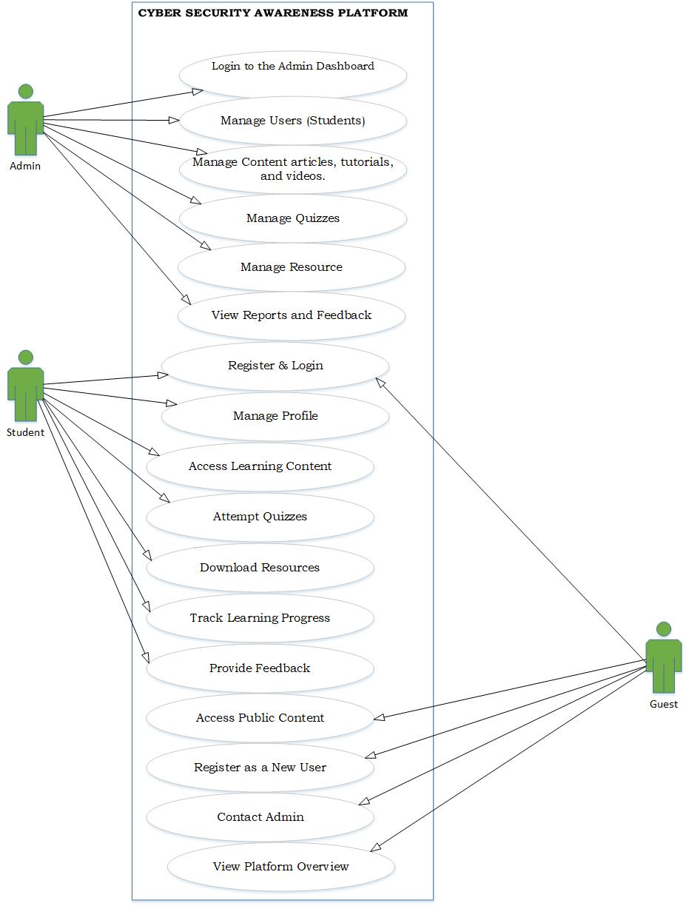

Fig:2.1 use case diagram

2.7 Use Case Descriptions
Admin Login
Field | Description
Use Case Name | Admin Login
Actor | Admin
Preconditions | Admin must be registered
Main Flow | 1. Enter credentials 2. Click login 3. System validates 4. Admin dashboard displayed
Alternate Flow | Invalid credentials → Error message
Post condition | Admin logged into dashboard

Tab 2.7.1
Student Register & Login
Field | Description
Use Case Name | Register & Login
Actor | Student
Preconditions | None (for registration)
Main Flow | 1. Enter details 2. Register 3. Login with credentials
Alternate Flow | Invalid input / duplicate account
Post condition | Student account created and logged in

Tab 2.7.2

Manage Users (Admin)
Field | Description
Use Case Name | Manage Users
Actor | Admin
Preconditions | Admin logged in
Main Flow | 1. View users 2. Add/Edit/Delete users
Alternate Flow | Invalid user data
Post condition | User data updated

Tab 2.7.3

Manage Content
Field | Description
Use Case Name | Manage Content
Actor | Admin
Preconditions | Admin logged in
Main Flow | 1. Add/Edit/Delete articles, tutorials, videos
Alternate Flow | Upload/content error
Post condition | Content updated in system

Tab 2.7.4
Manage Quizzes (Admin)
Field | Description
Use Case Name | Manage Quizzes
Actor | Admin
Preconditions | Admin logged in
Main Flow | 1. Create/Edit/Delete quizzes
Alternate Flow | Invalid quiz data
Post condition | Quiz database updated

Tab 2.7.5

Manage Resources
Field | Description
Use Case Name | Manage Resources
Actor | Admin
Preconditions | Admin logged in
Main Flow | 1. Upload/Delete resources
Alternate Flow | File upload error
Post condition | Resources available to users

Tab 2.7.6
View Reports & Feedback
Field | Description
Use Case Name | View Reports & Feedback
Actor | Admin
Preconditions | Admin logged in
Main Flow | 1. View reports 2. Analyze feedback
Alternate Flow | No data available
Post condition | Insights obtained

Tab 2.7.7
Manage Profile (Student)
Field | Description
Use Case Name | Manage Profile
Actor | Student
Preconditions | Student logged in
Main Flow | 1. Edit profile 2. Save changes
Alternate Flow | Invalid input
Post condition | Profile updated

Tab 2.7.8
Access Learning Content
Field | Description
Use Case Name | Access Learning Content
Actor | Student
Preconditions | Student logged in
Main Flow | 1. Browse content 2. View tutorials/videos
Alternate Flow | Content not available
Post condition | Learning content accessed

Tab 2.7.9
Attempt Quizzes
Field | Description
Use Case Name | Attempt Quizzes
Actor | Student
Preconditions | Student logged in
Main Flow | 1. Select quiz 2. Answer questions 3. Submit
Alternate Flow | Time out / incomplete submission
Post condition | Score generated

Tab 2.7.10
Download Resources
Field | Description
Use Case Name | Download Resources
Actor | Student
Preconditions | Student logged in
Main Flow | 1. Select resource 2. Download file
Alternate Flow | Download error
Post condition | Resource saved locally

Tab 2.7.11
Track Learning Progress
Field | Description
Use Case Name | Track Learning Progress
Actor | Student
Preconditions | Student logged in
Main Flow | 1. View progress dashboard
Alternate Flow | No progress data
Post condition | Progress displayed

Tab 2.7.12

Access Public Content
Field | Description
Use Case Name | Access Public Content
Actor | Guest
Preconditions | None
Main Flow | 1. Browse public pages
Alternate Flow | Content unavailable
Post condition | Public content viewed

Tab 2.7.13
Register as New User
Field | Description
Use Case Name | Register New User
Actor | Guest
Preconditions | None
Main Flow | 1. Fill registration form 2. Submit
Alternate Flow | Invalid details
Post condition | Account created

Tab 2.7.14
View Platform Overview
Field | Description
Use Case Name | View Platform Overview
Actor | Guest
Preconditions | None
Main Flow | 1. Open overview page
Alternate Flow | Page not loading
Post condition | Platform information displayed

Tab 2.7.15

CHAPTER 3: DESIGN AND ANALYSIS

3.1 System Architecture

3.1.1 2-tier / 3-tier diagram Client-Server architecture

Fig3.1 system architecture

3.2 Data Flow Diagram

3.2.1 Context Level (Level 0)
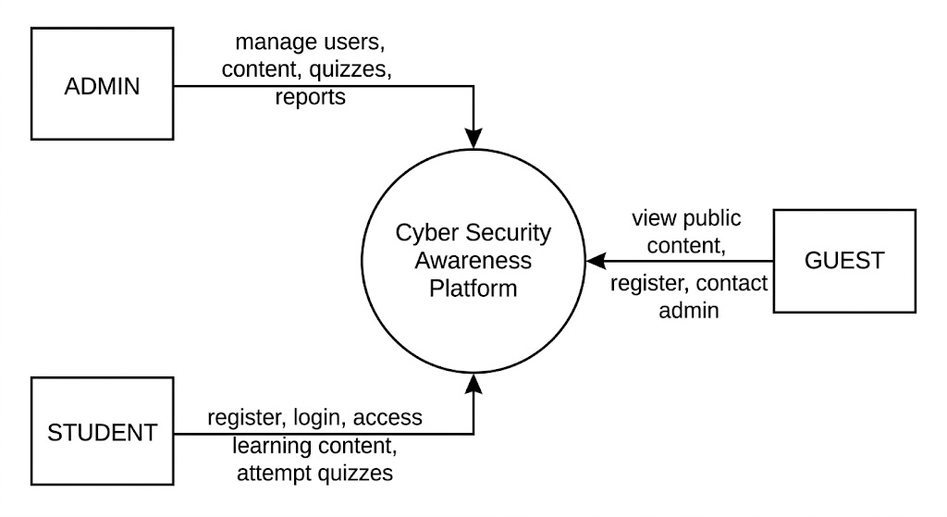

Fig 3.2 DFD

3.3 Entity Relationship Diagram (ERD)

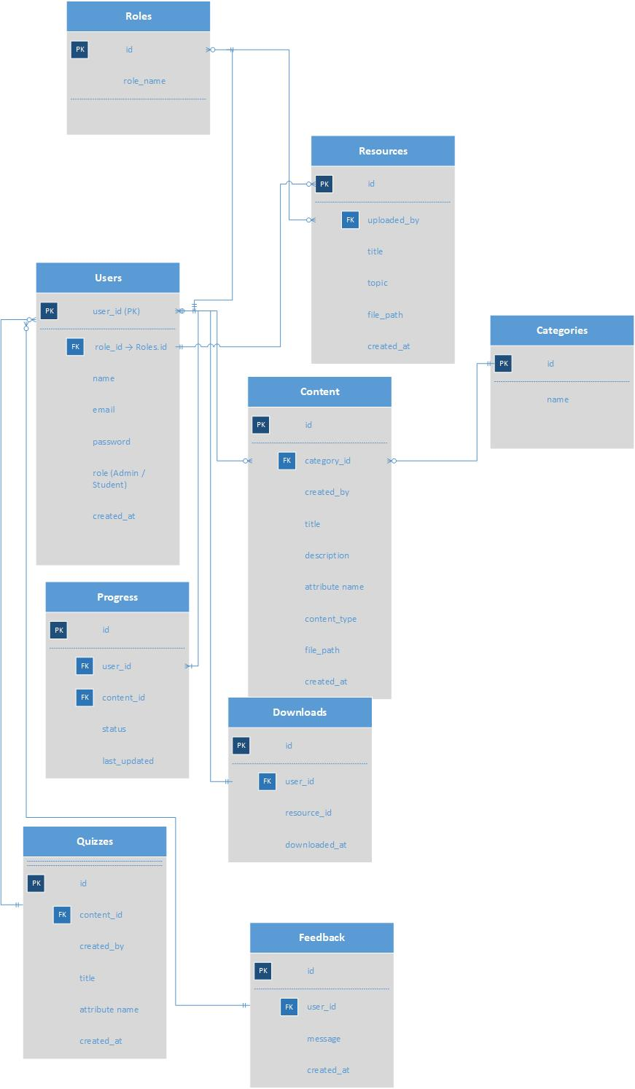

Fig 3.3 ERD

3.4 UML Diagrams

3.4.1 Class Diagram
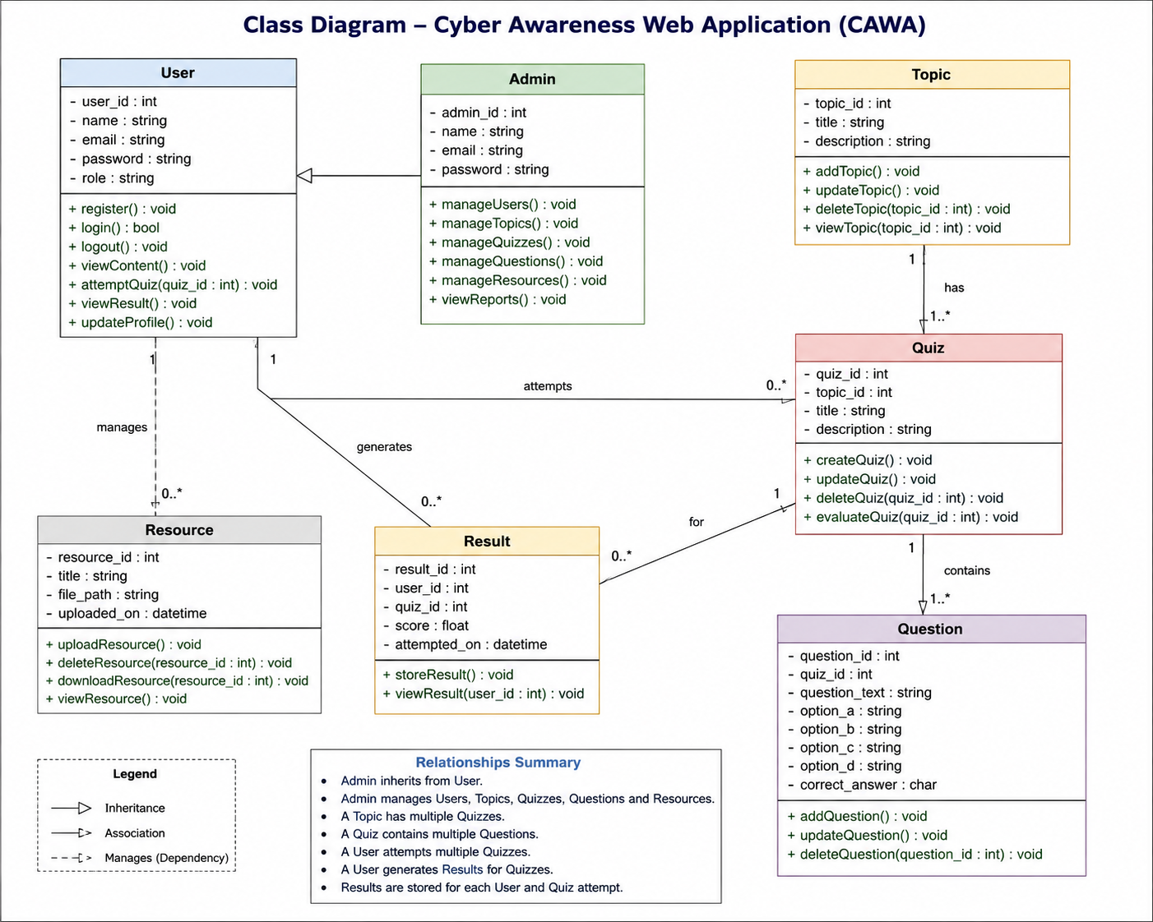

3.4.2Sequence Diagram

Fig3.4.2.1

Fig3.4.2.2

3.5 Database Design
The database of the Cyber Awareness Platform is designed using MySQL. The following tables are used in the system:

1. Roles Table
Table Name | Field Name | Data Type | Description
Roles | role_id | INT (PK, AI) | Unique role ID
Roles | role_name | VARCHAR(50) | Role name (Admin, Student, Guest)

Table3.1

2. Users Table
Table Name | Field Name | Data Type | Description
Users | user_id | INT (PK, AI) | Unique user ID
Users | role_id | INT (FK) | References roles table
Users | full_name | VARCHAR(100) | User full name
Users | Email | VARCHAR(100) | User email (unique)
Users | Password | VARCHAR(255) | Encrypted password
Users | Status | ENUM | Active / Inactive
Users | created_at | TIMESTAMP | Account creation date

Table3.2

3. Categories Table
Table Name | Field Name | Data Type | Description
categories | category_id | INT (PK, AI) | Unique category ID
categories | category_name | VARCHAR(100) | Category title
categories | Description | TEXT | Category description
categories | created_at | TIMESTAMP | Creation date

Table3.3

4. Topics Table
Table Name | Field Name | Data Type | Description
topics | topic_id | INT (PK, AI) | Unique topic ID
topics | category_id | INT (FK) | References categories
topics | Title | VARCHAR(200) | Topic title
topics | Content | TEXT | Topic details
topics | created_by | INT (FK) | Admin who created topic
topics | created_at | TIMESTAMP | Creation date

Table3.4

5. Quizzes Table
Table Name | Field Name | Data Type | Description
Quizzes | quiz_id | INT (PK, AI) | Unique quiz ID
Quizzes | topic_id | INT (FK) | References topics
Quizzes | quiz title | VARCHAR(200) | Quiz title
Quizzes | total_questions | INT | Total number of questions
Quizzes | created_at | TIMESTAMP | Quiz creation date

Table3.5

6. Questions Table
Table Name | Field Name | Data Type | Description
questions | question_id | INT (PK, AI) | Unique question ID
questions | quiz_id | INT (FK) | References quizzes
questions | Question | TEXT | Question text
questions | option_a | VARCHAR(255) | Option A
questions | option_b | VARCHAR(255) | Option B
questions | option_c | VARCHAR(255) | Option C
questions | option_d | VARCHAR(255) | Option D
questions | correct_option | CHAR(1) | Correct answer (A/B/C/D)

Table3.6

7. Quiz Attempts Table
Table Name | Field Name | Data Type | Description
quiz_attempts | attempt_id | INT (PK, AI) | Unique attempt ID
quiz_attempts | quiz_id | INT (FK) | References quizzes
quiz_attempts | user_id | INT (FK) | References users
quiz_attempts | Score | INT | Obtained score
quiz_attempts | attempt date | TIMESTAMP | Attempt date

Table3.7

8. Quiz Answers Table
Table Name | Field Name | Data Type | Description
quiz_answers | answer_id | INT (PK, AI) | Unique answer ID
quiz_answers | attempt_id | INT (FK) | References quiz_attempts
quiz_answers | question_id | INT (FK) | References questions
quiz_answers | selected option | CHAR(1) | Selected answer

Table3.8

9. Resources Table
Table Name | Field Name | Data Type | Description
resources | resource_id | INT (PK, AI) | Unique resource ID
resources | topic_id | INT (FK) | References topics
resources | Title | VARCHAR(200) | Resource title
resources | file_path | VARCHAR(255) | PDF file path
resources | uploaded_at | TIMESTAMP | Upload date

Table3.9

10. Downloads Table
Table Name | Field Name | Data Type | Description
Downloads | download_id | INT (PK, AI) | Unique download ID
downloads | resource_id | INT (FK) | References resources
downloads | user_id | INT (FK) | References users
downloads | download_date | TIMESTAMP | Download date

Table3.10

11. Feedback Table
Table Name | Field Name | Data Type | Description
feedback | feedback_id | INT (PK, AI) | Unique feedback ID
feedback | user_id | INT (FK) | References users
feedback | Message | TEXT | User feedback
feedback | submitted at | TIMESTAMP | Submission date

Table3.11

3.6 User Interface Design
The User Interface (UI) of the Cyber Awareness Platform is designed to be simple, user-friendly, and accessible to users with basic technical knowledge. The interface focuses on clean layout, easy navigation, and readability to ensure effective learning.
The platform provides different interfaces based on user roles:
- Guest Interface: Allows new users to browse basic content and register on the platform. It includes pages like Home, Topics, and Registration.
- Student Interface: After login, students can access the dashboard, view learning materials, attempt quizzes, and check their results. The design ensures smooth navigation between topics, quizzes, and progress tracking.
- Admin Interface: Admins have a separate dashboard to manage users, topics, quizzes, and reports. The interface includes forms for data entry and tables for monitoring system activities.
The UI uses a consistent design structure with a header, navigation menu, content area, and footer. Basic CSS styling is applied to enhance visual appearance, including proper spacing, buttons, and readable fonts.
Overall, the interface is designed to support easy interaction, quick access to learning resources, and an efficient user experience across all user types.
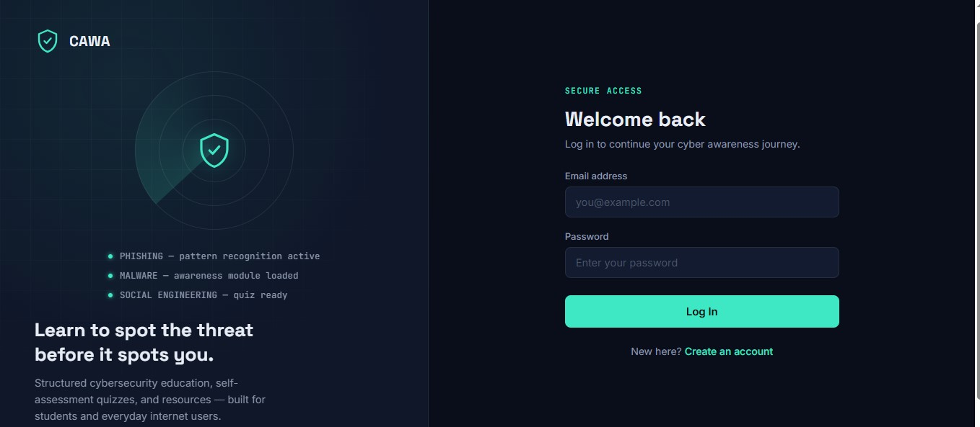

Fig 3.6 Home page interface

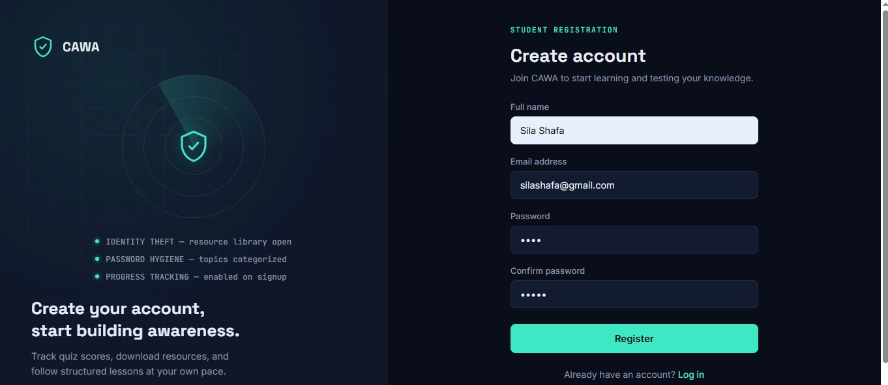

Fig 3.6 Register page

3.6.1 Wireframes
Wireframes for this project represent the basic layout of pages such as Home, Login, Admin Dashboard, Student Dashboard, and Quiz pages. They show placement of menus, buttons, content sections, and navigation flow without colors or styling.
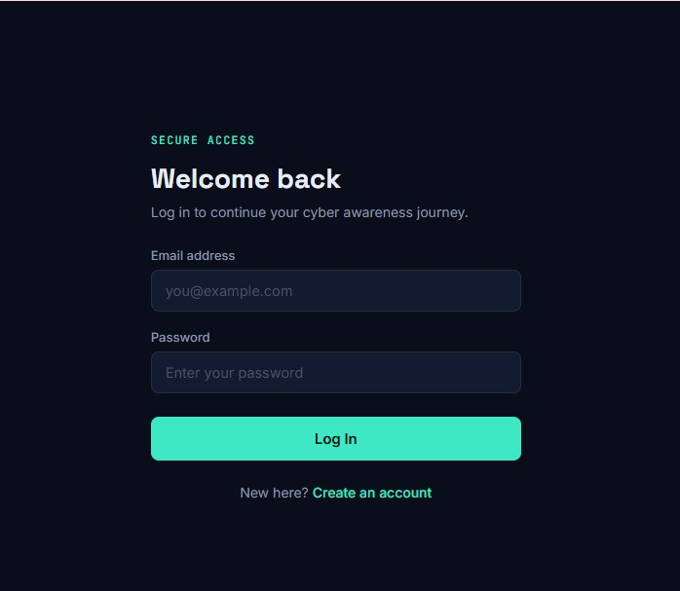

Fig 3.7 login page

3.6.2 Mockups
Mockups show the final visual design of the platform, including colors, fonts, and styling. For this system, mockups include a clean homepage, user-friendly dashboards, quiz interface, and admin panel with properly styled tables and forms.
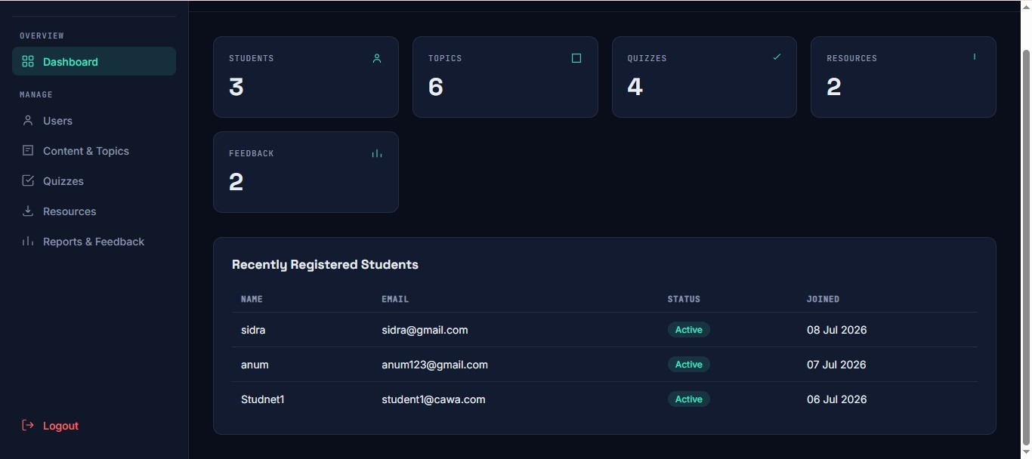

Fig 3.6.2 admin Dashboard

3.6.3 Navigation structure
The navigation structure defines how users move through the system.
- Guest: Home → Register/Login → Browse Topics
- Student: Login → Dashboard → Topics → Quiz → Results
- Admin: Login → Dashboard → Manage Users/Topics/Reports

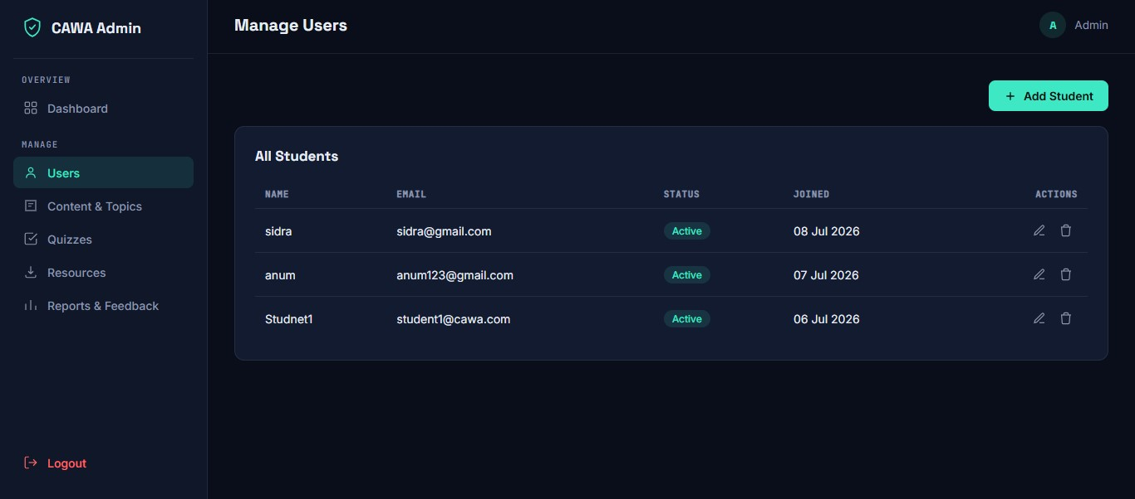

Fig 3.6.3 manage user page
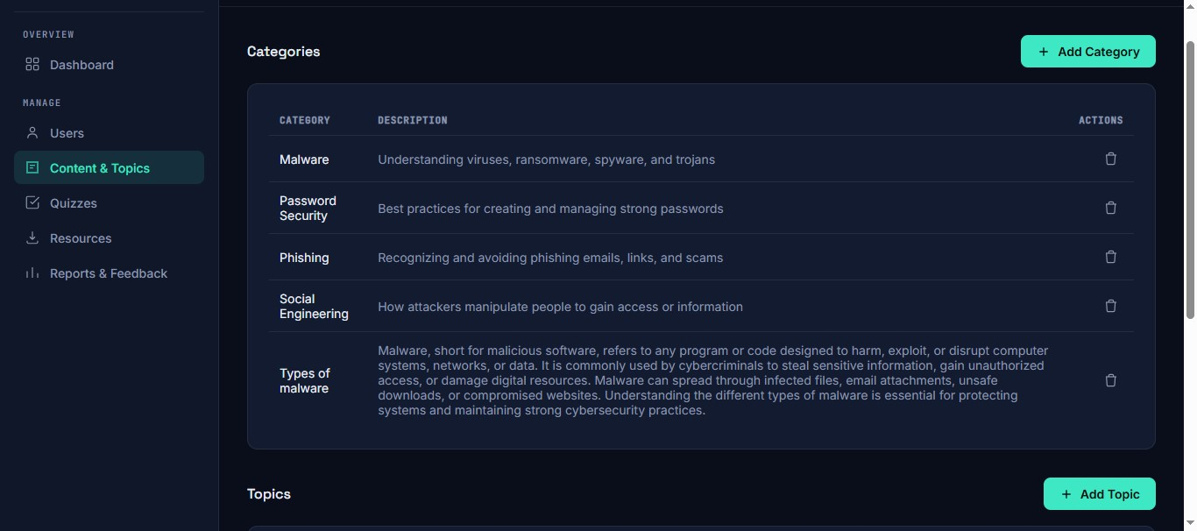

Fig 3.6.4 content and topic
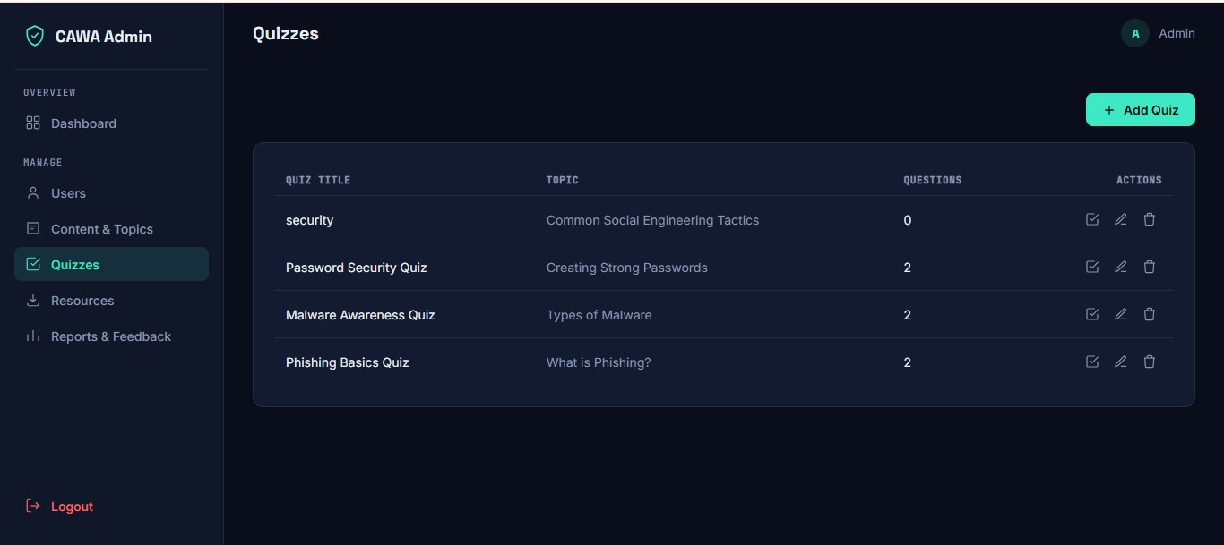

Fig 3.6.5 quiz page

CHAPTER 4: DEVELOPMENT

4.1 Development Environment
The development environment defines the tools, technologies, and platforms used to design and implement the Cyber Awareness Web Application (CAWA). The system was developed using a combination of modern web technologies to ensure efficiency, scalability, and ease of use.

4.1.1 Operating System (OS)
The system was developed on a Windows-based operating system. Windows provides a user-friendly interface and strong support for web development tools such as XAMPP, which simplifies the setup of a local server environment including Apache and MySQL.

4.1.2 Integrated Development Environment (IDE)
The primary IDE used for development was Visual Studio Code (VS Code). It is a lightweight yet powerful code editor that supports multiple programming languages including PHP, HTML, CSS, and JavaScript. Features such as syntax highlighting, extensions, debugging tools, and version control integration significantly improved development productivity.

4.1.3 Framework / Technologies
The application was developed using the following technologies:
- Core PHP – Used for server-side scripting and backend logic implementation.
- MySQL – Used as the database management system to store user data, quiz information, and learning resources.
- HTML (HyperText Markup Language) – Used to structure the web pages.
- CSS (Cascading Style Sheets) – Used for styling and layout design.
- Bootstrap – Used to create a responsive and mobile-friendly user interface.
- JavaScript – Used to add interactivity and dynamic behavior to the web pages.
These technologies collectively ensured that the system is dynamic, responsive, and user-friendly.

4.1.4 Version Control
Version control was not formally implemented during the development of this project. However, manual backups and file versioning techniques were used to manage different versions of the system during development. For future improvements, tools like Git can be used to maintain code history and support collaborative development.

4.2 System Modules
The Cyber Awareness Web Application (CAWA) is divided into several functional modules. Each module is responsible for handling specific operations within the system. This modular design improves maintainability, scalability, and system organization.

4.2.1 Authentication Module
The Authentication Module is responsible for managing user access to the system. It ensures that only authorized users can access protected features.
- Provides user registration functionality for new users.
- Allows existing users to log in using valid credentials (username/email and password).
- Implements session management to maintain user login state.
- Ensures secure access by restricting unauthorized users from accessing system features.
- Includes logout functionality to safely terminate user sessions.
This module plays a critical role in maintaining the security and integrity of the system.

4.2.2 Admin Module
The Admin Module provides administrative control over the entire system. It allows the administrator to manage content, users, and system operations through a dedicated dashboard.
- Manage user accounts (view, add, update, delete users).
- Create, update, and delete cybersecurity topics and categories.
- Manage quizzes and questions for different topics.
- Upload and manage learning resources such as PDF files.
- Monitor system activity and overall platform usage.
This module ensures that the system content remains updated, organized, and relevant.

4.2.3 Reporting Module
The Reporting Module is responsible for generating and displaying system-related reports. It helps administrators track performance and user activity.
- Generate reports on user registrations and activity.
- Display quiz results and user performance statistics.
- Provide insights into system usage and engagement levels.
- Allow administrators to view summarized data for decision-making.
This module enhances system transparency and supports effective management.

4.2.4 Transaction Module
The Transaction Module handles all system interactions related to user activities and data processing. Although the system does not involve financial transactions, this module manages logical transactions within the platform.
- Handles user interactions such as quiz attempts and submissions.
- Processes data related to user progress and scores.
- Manages storage and retrieval of user-related data from the database.
- Ensures data consistency and integrity during system operations.

4.3 Key Implementation Details
This section explains the core implementation aspects of the Cyber Awareness Web Application (CAWA), including the algorithms used, validation mechanisms, and business rules applied throughout the system.

4.3.1 Algorithms
The system uses simple and efficient algorithms to handle user interactions, authentication, and quiz processing.
1. User Authentication Algorithm
- User enters email and password.
- System retrieves stored user data from the database.
- Password is compared (hashed comparison).
- If credentials match → user is granted access.
- Otherwise → error message is displayed.
2. Quiz Evaluation Algorithm
- User selects answers and submits the quiz.
- System compares selected answers with correct answers stored in the database.
- Score is calculated by counting correct responses.
- Result is stored in the database.
- Feedback is displayed to the user.
Sample Pseudocode:
score = 0
for each question:
if user_answer == correct_answer:
score = score + 1
store score in database
display result
3. Data Retrieval Algorithm
- User requests content (topics/resources).
- System sends query to database.
- Results are fetched and displayed dynamically on the web page.

4.3.2 Validation Logic
Validation is implemented to ensure data accuracy, security, and proper system functioning.
1. Client-Side Validation
- Implemented using JavaScript.
- Checks for empty fields, valid email format, and password length.
- Provides immediate feedback to users without reloading the page.
2. Server-Side Validation
- Implemented using PHP.
- Ensures all inputs are validated before processing.
- Prevents invalid or malicious data from being stored in the database.
3. Input Security Validation
- Special characters are sanitized to prevent SQL Injection.
- User inputs are validated using filtering and escaping techniques.
Example (PHP Validation Snippet):
$email = filter_var($_POST['email'], FILTER_SANITIZE_EMAIL);
if (!filter_var($email, FILTER_VALIDATE_EMAIL)) {
echo "Invalid email format";
}

4.3.3 Business Rules
Business rules define how the system behaves and enforces constraints.
- Only registered users can access quizzes and track progress.
- Admin has full control over system data (users, topics, quizzes, resources).
- Users must log in before attempting quizzes.
- Each quiz submission is recorded and cannot be altered by the user.
- Users can only view their own results and progress.
- Content (topics/resources) must be managed and approved by the admin.
- System ensures proper session handling (automatic logout after inactivity).
These rules ensure system consistency, data integrity, and controlled access.

4.4 APIs / Third Party Integrations
The Cyber Awareness Web Application (CAWA) is primarily developed using core web technologies and does not heavily rely on external APIs. However, some third-party libraries and tools have been integrated to enhance the functionality, user interface, and overall user experience of the system.

4.4.1 Bootstrap Framework
- Purpose: Used for designing a responsive and mobile-friendly user interface.
- Integration Type: Front-end CSS framework.
- Usage: Provides pre-designed components such as navigation bars, forms, buttons, and grids.
- Benefit: Ensures consistent design and responsiveness across different devices and screen sizes.

4.4.2 JavaScript Libraries
- Purpose: Enhance interactivity and improve user experience.
- Integration Type: Client-side scripting.
- Usage: Used for form validation, dynamic content updates, and UI interactions.
- Benefit: Reduces page reloads and improves system responsiveness.

4.4.3 jQuery (Optional Usage)
- Purpose: Simplifies JavaScript operations and DOM manipulation.
- Integration Type: JavaScript library.
- Usage: Handles events, animations, and AJAX requests (if implemented).
- Benefit: Makes front-end development faster and more efficient.

4.4.4 XAMPP (Development Tool)
- Purpose: Provides a local server environment for development and testing.
- Integration Type: Development environment tool (Apache + MySQL + PHP).
- Usage: Hosts the application locally during development.
- Benefit: Enables easy setup and testing without requiring live deployment.

4.4.5 Database Integration (MySQL)
- Purpose: Data storage and management.
- Integration Type: Backend database system.
- Usage: Stores user data, quiz information, results, and resources.
- Benefit: Ensures efficient data retrieval and secure storage.

Summary
The system does not currently integrate with external web APIs (such as payment gateways or third-party authentication services). Instead, it relies on built-in technologies and lightweight third-party libraries to maintain simplicity, reliability, and ease of deployment.
For future enhancements, APIs such as email services, cloud hosting platforms, or AI-based recommendation systems can be integrated to extend system capabilities.

CHAPTER 5: SOFTWARE TESTING

5.1 Testing Strategy
Software testing is a critical phase of the Software Development Life Cycle (SDLC). It ensures that the developed system works correctly, meets requirements, and is free from major defects.
In Final Year Projects (FYPs), testing demonstrates:
•System correctness
• Functional completeness
• Error handling capability
• Real-world usability
Definition
Software testing is the process of executing a program to find errors and verify that it meets its requirements. A testing strategy defines how the software will be tested, what levels of testing will be used, and the approach to ensure quality. In this project (Cyber Awareness System), testing was performed at four main levels:

5.1.1 Unit Testing
Definition:
Unit testing involves testing individual components or modules of the system separately to ensure each unit functions correctly.
Purpose:
• To verify the correctness of each function
• To identify errors at an early stage
In This Project:
Unit testing was performed on modules such as login validation, quiz processing, and content management to ensure each function works independently.
Key Point:
All modules were tested individually before combining them into the complete system.
Example (FYP Context):
• Testing Log invalidation() function
• Testing quiz submission functionality
• Testing content upload module
Example Test Case:
• Input: Username = "admin", Password = "1234"
• Expected Output: Successful login
• Actual Output: Successful login
• Status: Pass

5.1.2 Integration Testing
Integration testing verifies the interaction between two or more modules.
Purpose:
• To ensure modules work together correctly
• To detect interface errors
Common Integration Approaches:
• Top-down integration
• Bottom-up integration
• Big-bang integration
Example (FYP Context):
• User module + Quiz module
• Quiz module + Result generation module
Example Scenario:
User starts quiz → submits answers → system calculates score → result is displayed correctly
Key Point for Report Writing:
Integration testing was performed to verify that all modules communicate correctly and data flows properly between components.

5.1.3 System Testing
System testing evaluates the complete and integrated system as a whole.
Purpose:
• Validate end-to-end functionality
• Ensure system meets requirements
Focus Areas:
• Functional requirements
• Usability
• Performance
• Security
Example (FYP Context):
• User registration → login → access awareness content → attempt quiz → view results
Example Scenario:
A complete workflow is tested from login to quiz completion and result generation
Key Point for Report Writing:
System testing ensures that the complete application works as expected in a real-world environment.

5.1.4 Acceptance Testing
Acceptance testing is performed to determine whether the system meets user requirements.
Types:
• Alpha Testing (performed in development environment)
• Beta Testing (performed by real users)
Example (FYP Context):
• Users test awareness content accessibility
• Users attempt quizzes and verify results
• Admin checks content management features
Key Point for Report Writing:
Acceptance testing was conducted with users to validate that the system fulfills all functional and usability requirements.

5.2 Test Plan
A test plan is a document that defines what to test, how to test, when to test, and who will perform the testing activities. It ensures that all system components are properly verified and validated.

5.2.1 Testing Objectives
The main objectives of testing in this Cyber Awareness System are:
• To identify defects and errors in the system
• To ensure all functional requirements are implemented correctly
• To verify system functionality such as login, content access, and quiz modules
• To ensure data accuracy and proper validation
• To ensure system stability under normal usage conditions

5.2.2 Scope of Testing
The scope defines what will and will not be tested in the system.
Included in Scope:
• User login and authentication
• Awareness content management module
• Quiz and result generation module
• Data validation and input handling
• CRUD operations (Create, Read, Update, Delete)
Excluded from Scope:
• Third-party APIs (if not developed in the project)
• External hardware integration
• Advanced load or stress testing

5.2.3. Testing Approach
The testing approach defines the method used to test the system.
Manual Testing:
• All system features were tested manually by the developer and users
• No automation tools were used
Black Box Testing:
• Testing was performed without knowledge of internal code
• Focus was on inputs and expected outputs
White Box Testing (Optional):
- Used to verify internal logic such as validation and database operation
- MS Excel (for documenting test cases)
Test Environment:
• Windows 10/11
• Web Browser (Chrome/Edge)
• MySQL / SQL Database
Entry Criteria:
• All modules are developed
• Database is properly connected
• Basic system functionality is working
Exit Criteria:
• All critical test cases are passed
• No major unresolved defects remain
• System is accepted by users

5.3 Test Cases

5.3.1 What is a Test Case? (Cyber Security Awareness Application)
A test case in a Cyber Security Awareness Application is a set of steps, conditions, and inputs used to verify whether a specific feature of the system—such as user login, phishing detection, quiz module, or security tips—is working correctly and securely.
A test case checks:
- What input is given? (e.g., username, password, quiz answer, URL)
- What should happen? (expected secure and correct behavior)
- What actually happens? (system’s real response)
In a cyber-awareness system, test cases are especially important because they ensure:
- The system properly protects user data
- Security-related features (like password validation, phishing alerts, quizzes) work correctly
- Users receive accurate awareness content
- The system behaves safely under both valid and malicious inputs

Example (Cyber Awareness Context)
- Checking if the system detects a weak password
- Verifying that a phishing link warning appears
- Testing if users can successfully complete awareness quizzes

5.3.2 Standard Test Case

Test Case ID | Description | Input | Expected Output | Actual Output | Status
TC01 | Valid login | Username: admin, Password: 1234 | Login successful | Login successful | Pass
TC02 | Invalid login | Username: admin, Password: 0000 | Error message | Error message | Pass
TC03 | Empty login fields | Username: "", Password: "" | Validation error | Validation error | Pass
TC04 | Valid registration | Valid user data | Account created | Account created | Pass
TC05 | Duplicate registration | Same username/email | Error message | Error message | Pass
TC06 | Missing registration fields | Empty fields | Validation error | Validation error | Pass
TC07 | Add awareness content | Valid content data | Content saved | Saved successfully | Pass
TC08 | View content | Click view | Content displayed | Displayed | Pass
TC09 | Update content | Edit data | Updated successfully | Updated | Pass
TC10 | Delete content | Click delete | Content removed | Removed | Pass
TC11 | Start quiz | Click start | Quiz begins | Started | Pass
TC12 | Submit quiz | Answer questions | Score generated | Score shown | Pass
TC13 | Submit empty quiz | No answers | Error message | Error shown | Pass
TC14 | View results | Click results | Results displayed | Displayed | Pass
TC15 | Unauthorized access | User opens admin panel | Access denied | Denied | Pass
TC16 | Logout | Click logout | Redirect to login | Redirected | Pass
TC17 | Invalid data input | Special characters | Validation error | Error shown | Pass
TC18 | Boundary test(short password) | Password < required length | Error message | Error shown | Pass
TC19 | Session timeout | Idle user | Auto logout | Logged out | Pass
TC20 | Page refresh after login | Refresh browser | Session maintained | Maintained | Pass

Table 5.1

5.4 Black Box Testing

5.4.1 Definition
Black Box Testing is a software testing technique in which the tester does not have knowledge of the internal code structure of the system. The testing is performed by focusing only on:
- Inputs
- Outputs
- System behavior
Simple Definition:
“Black box testing is the process of verifying whether the system produces the correct output for given inputs without understanding the internal code logic.”
According to Cyber Security Awareness Application:
In this project, black box testing is used to check features such as user login, password validation, phishing detection, quiz system, and security alerts by providing different inputs and verifying correct system responses.

5.4.2 Key Characteristics
- No knowledge of internal code is required
- Focus on user requirements and system functionality
- Tests only input-output behavior
- Easy to perform and widely used in FYPs
- Helps identify missing or incorrect functionalities

5.4.3 Common Black Box Testing Techniques
A. Equivalence Partitioning
In this technique, input data is divided into valid and invalid groups to reduce the number of test cases.
Example (Password Strength in Cyber Awareness System):
- Valid: Strong password (e.g., Abc@1234)
- Invalid: Weak password (e.g., 12345)
Input | Expected Output
Abc@1234 | Accepted (Strong)
12345 | Rejected (Weak)
Password | Rejected

Table 5.2
B. Boundary Value Analysis (BVA)
This technique tests values at the edge (minimum and maximum limits).

Input Length | Expected Output
7 | Invalid
8 | Valid
16 | Valid
17 | Invalid

Table5.3
C. Decision Table Testing
Used when system behavior depends on multiple conditions.
Example (Login System):
Username Valid | Password Valid | Result
Yes | Yes | Login Success
Yes | No | Error Message
No | Yes | Error Message
No | No | Error Message

Table 5.4
D. State Transition Testing
This technique checks how the system changes from one state to another based on user actions.
Example (User Session in Cyber Awareness System):
- Logged Out → User logs in → Logged In
- Logged In → User logs out → Logged Out
- Logged In → Session timeout → Logged Out

5.4.4 Black Box Testing Example (FYP Context)
Project: Cyber Security Awareness Application
Testing focuses on:
- User registration and login system
- Password strength validation
- Phishing link detection module
- Quiz and awareness content delivery
- Alert messages and feedback system
Example Scenario:
- User enters a suspicious URL → System checks → Displays warning
- User submits quiz → System calculates score → Shows result

5.4.5 Report Writing Paragraph
“Black box testing was performed on the Cyber Security Awareness Application to validate system functionality based on input and output behavior. The internal code structure was not considered during testing. Various techniques such as equivalence partitioning, boundary value analysis, decision table testing, and state transition testing were applied to ensure the correctness and reliability of system features such as login, password validation, phishing detection, and quiz modules.”

Chapter 6: Implementation

6.1 Hardware Requirements
The hardware requirements define the minimum and recommended system specifications needed to develop and run the Cyber Awareness Web Application (CAWA). Since the system is a web-based application developed using lightweight technologies, it does not require high-end hardware.

6.1.1 Minimum Hardware Requirements
The following specifications are sufficient for basic development and testing:
- Processor: Intel Core i3 or equivalent
- RAM: 4 GB
- Hard Disk: 500 GB HDD or 128 GB SSD
- System Type: 64-bit Operating System
- Input Devices: Keyboard and Mouse
- Display: Standard Monitor

6.1.2 Recommended Hardware Requirements
For better performance and smoother development experience:
- Processor: Intel Core i5 or above
- RAM: 8 GB or higher
- Storage: 256 GB SSD or higher
- System Type: 64-bit Operating System
- Display: Full HD Monitor

6.1.3 Additional Requirements
- A stable system capable of running a local server environment (e.g., XAMPP).
- Internet connection (optional) for downloading libraries, documentation, and future deployment.

Summary
The CAWA system is designed to be lightweight and efficient, ensuring that it can run on standard computing systems without requiring specialized or expensive hardware. This makes the application accessible for both developers and end users.

6.2 Software Requirements
The software requirements define the tools, platforms, and technologies required to develop, run, and maintain the Cyber Awareness Web Application (CAWA). The system is built using widely available and open-source technologies, making it cost-effective and easy to deploy.

6.2.1 Operating System
- Windows 10/11 (Recommended)
- Other operating systems such as Linux or macOS can also be used for development and deployment.

6.2.2 Web Server Environment
- XAMPP (Apache Server)
  - Provides an integrated environment including Apache, PHP, and MySQL.
  - Used for local development and testing of the web application.

6.2.3 Programming Languages
- PHP (Core PHP): Used for backend development and server-side logic.
- HTML: Used for structuring web pages.
- CSS: Used for styling and layout design.
- JavaScript: Used for interactivity and client-side validation.

6.2.4Database Management System
- MySQL
  - Used to store and manage system data such as users, quizzes, results, and resources.
  - Integrated with PHP for dynamic data handling.

6.2.5 Frontend Framework / Libraries
- Bootstrap
  - Used to design responsive and mobile-friendly user interfaces.
- jQuery (Optional)
  - Used to simplify JavaScript operations and enhance UI interactions.

6.2.6 Development Tools (IDE / Editor)
- Visual Studio Code (VS Code)
  - Used for writing and editing code.
  - Supports extensions for PHP, HTML, CSS, and JavaScript.

6.2.7 Web Browser
- Google Chrome / Microsoft Edge
  - Used for testing and running the web application.
  - Provides developer tools for debugging and performance analysis.

Summary
The CAWA system uses a standard web development stack consisting of PHP, MySQL, and frontend technologies. These tools are easy to install, widely supported, and suitable for building scalable web applications.

6.3 Installation Procedure

6.3.1. XAMPP Control Panel
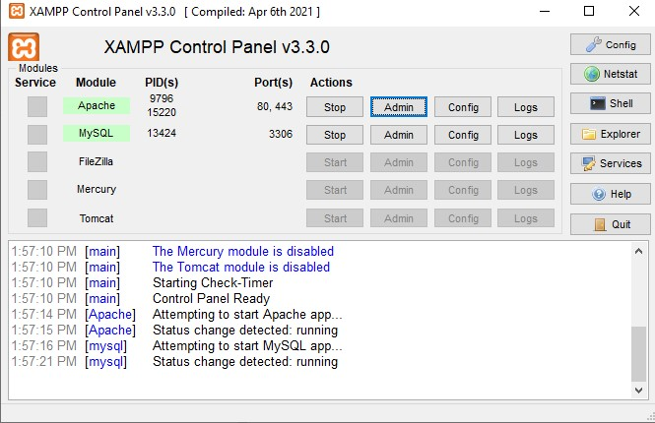

Figure 6.1: XAMPP Control Panel with Apache and MySQL Running

6.3.2phpMyAdmin Dashboard
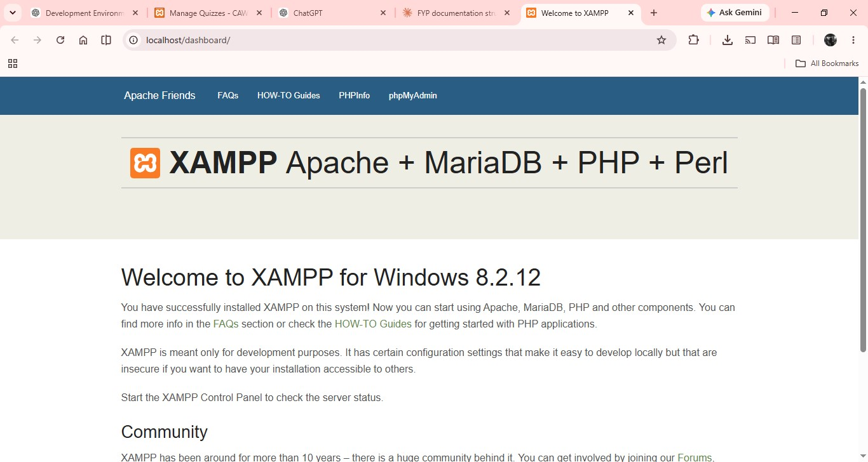

Figure 6.2: phpMyAdmin Dashboard

6.3.3Database Creation Screen
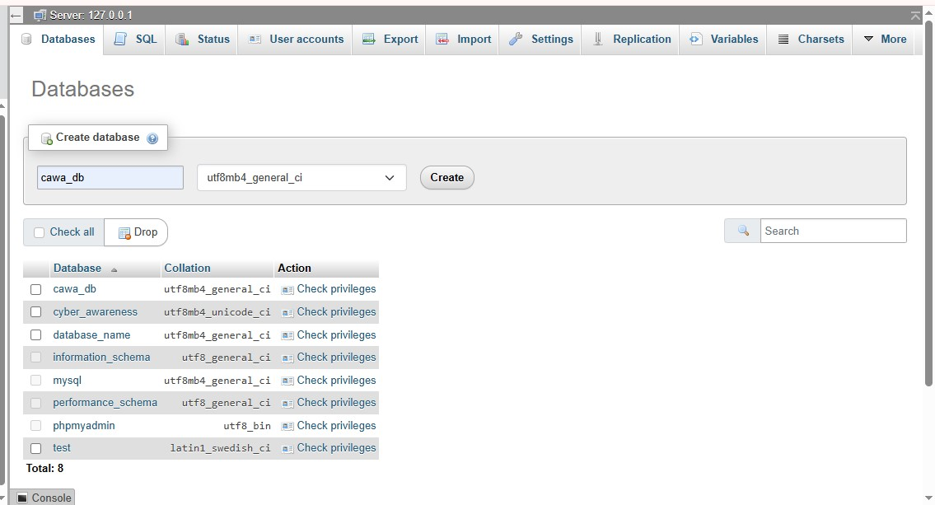

Figure 6.3: Database Creation Screen

6.3.4 Created Database Screen
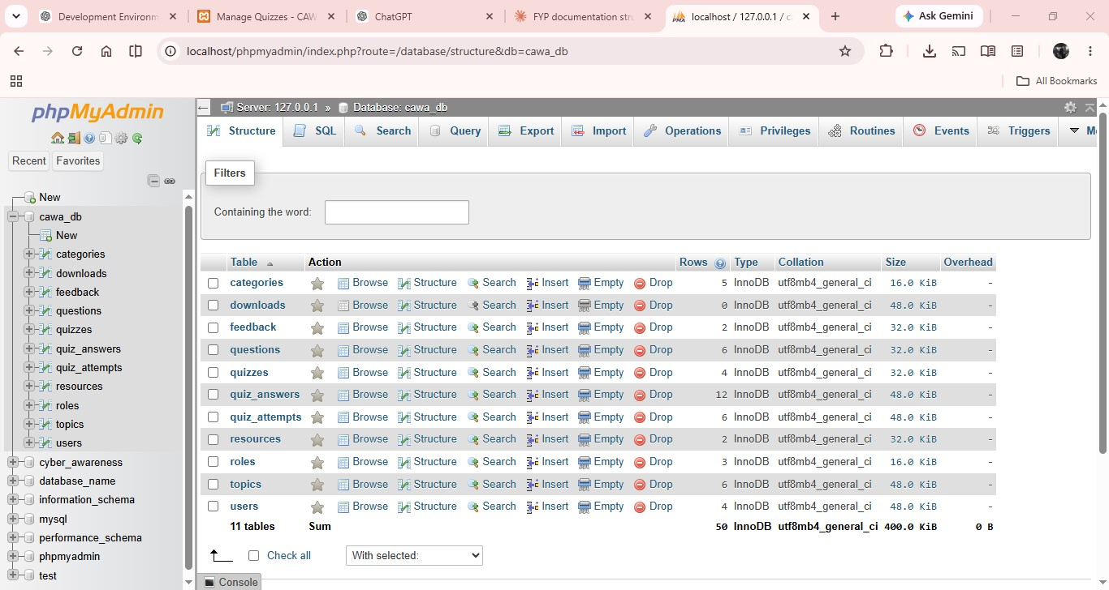

Figure 6.4: Created Database Screen

6.3.5 Project Folder in htdocs

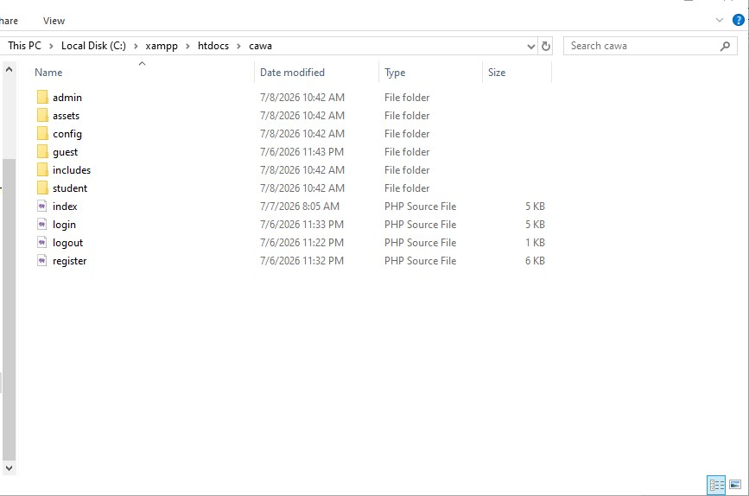

Figure 6.3.5: Project Directory in htdocs Folder

6.3.6 Database Configuration File

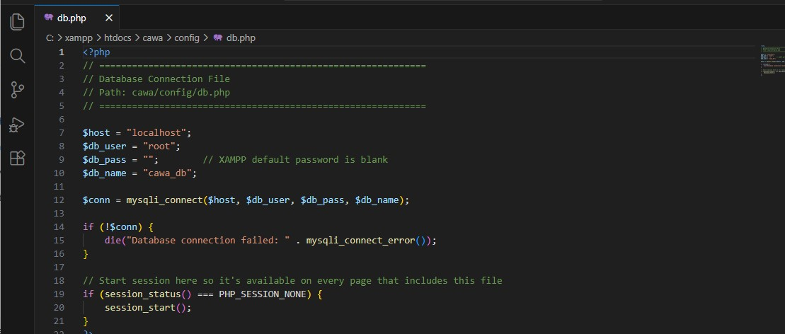

Figure 6.6: Database Configuration File

6.3.7. Application Home Page


Figure 6.7: CAWA Home Page

6.3.8 User Registration Page



Figure 6.8: User Registration Page

6.3.9 Login Page


Figure 6.9: User Login Page

6.3.10 User Dashboard 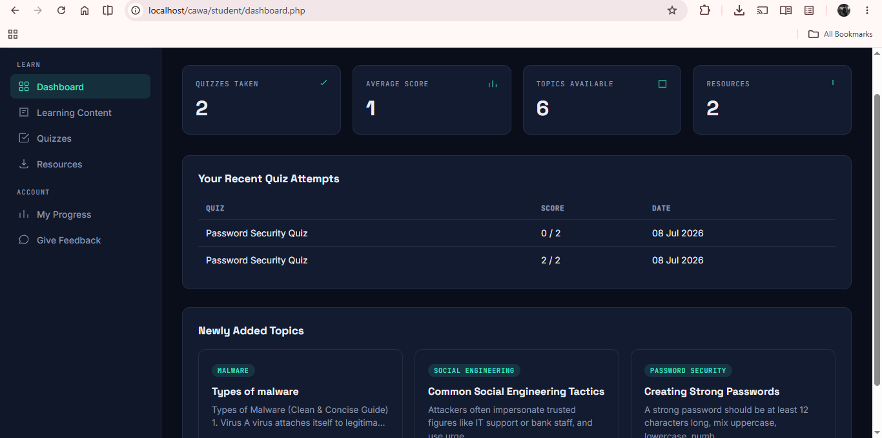

Figure 6.10: User Dashboard

6.3..11 Quiz Interface

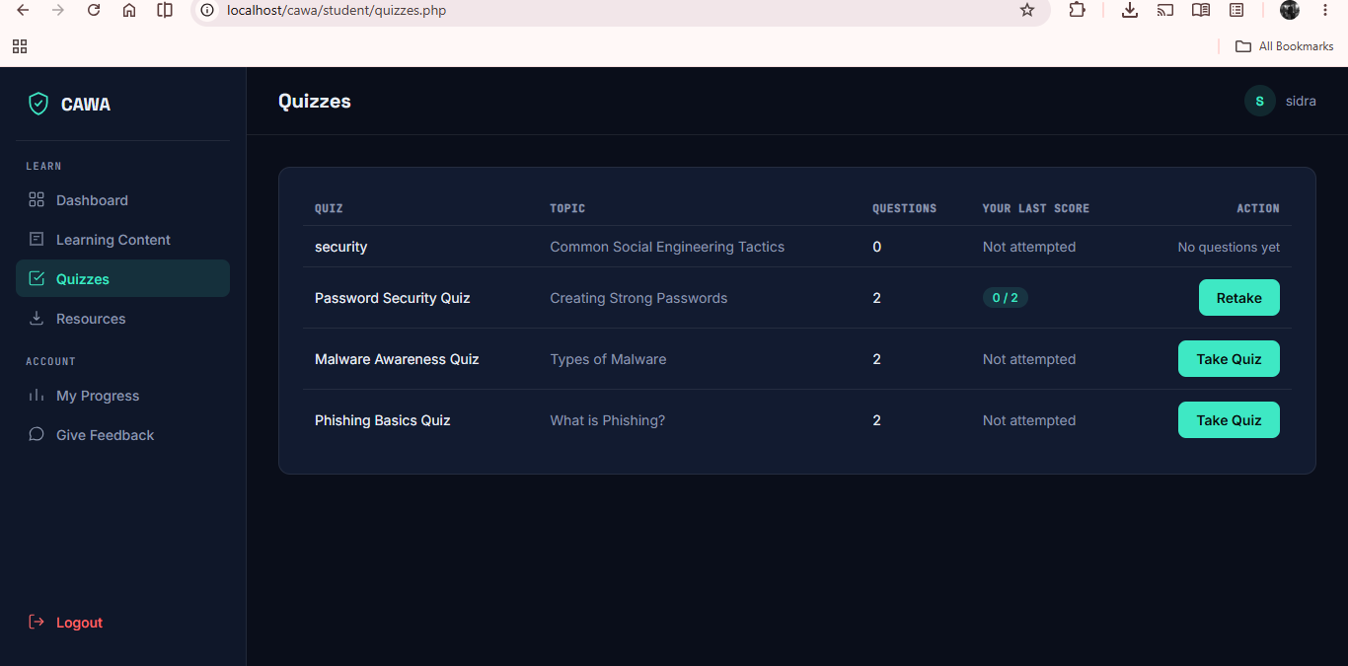

Figure 6.11: Quiz Interface

6.3.12 Admin Dashboard


Figure 6.12: Admin Dashboard

6.3.13 Manage Content (Admin)


Figure 6.13: Admin Content Management Panel

6.4 Deployment Details
This section describes the environment and configuration used to deploy the Cyber Awareness Web Application (CAWA). Currently, the system is deployed on a local server for development and testing purposes.

Hosting Environment
The CAWA system is hosted on a local server environment using XAMPP.
- The application runs on Apache Web Server provided by XAMPP.
- The backend is powered by PHP, while MySQL is used for database management.
- The system is accessed through a web browser using the URL:
http://localhost/cawa
This local hosting setup allows easy development, testing, and debugging without requiring an internet connection. However, it limits access to only the local machine.
For future deployment, the system can be hosted on live servers such as:
- Shared hosting (cPanel-based hosting)
- Cloud platforms (e.g., AWS, DigitalOcean)

Server Configuration
The server is configured using the default XAMPP settings with minor adjustments:
- Web Server: Apache
- Database Server: MySQL
- Server-side Language: PHP
Configuration Details:
- Apache and MySQL services must be running before accessing the system.
- Project files are stored in the htdocs directory of XAMPP.
- Database connection is configured in the config.php file.
- Default MySQL credentials used:
  - Username: root
  - Password: (empty)
PHP Configuration (Typical Settings):
- Error reporting enabled for debugging during development.
- File upload support enabled (for resource uploads).

6.5 User Manual
This section provides a step-by-step guide for users to interact with the Cyber Awareness Web Application (CAWA). It explains how to log in, perform key operations, and view reports.

1. User Login

Steps to Login:
- Open a web browser.
- Enter the URL: http://localhost/cawa
- Click on the Login button.
- Enter your registered email and password.
- Click Login to access the system.

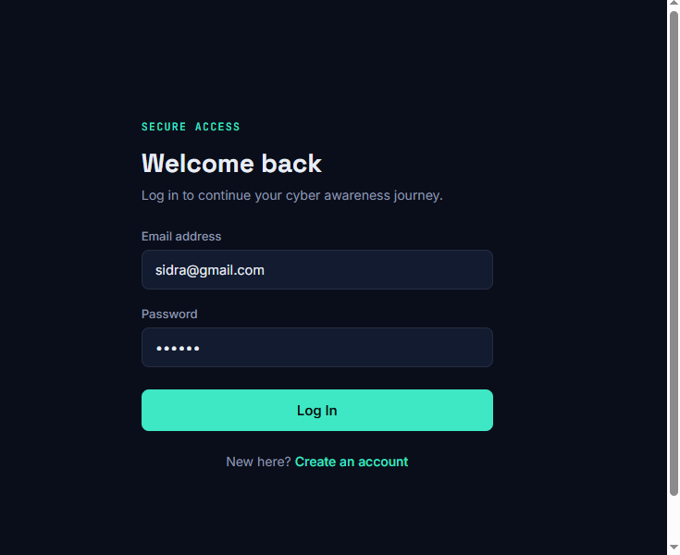

Figure 6.14: User Login Page

2. Perform Operations
After successful login, users can perform the following operations:

2.1 View Learning Content
Steps:
- Navigate to the Topics / Learning Section.
- Select a cybersecurity topic.
- Read the provided educational content.
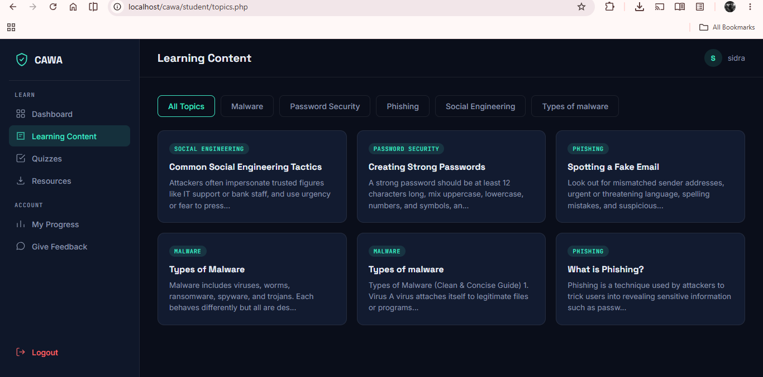

Figure 6.15: Learning Content Page

2.2 Attempt Quiz
Steps:
- Click on the Quiz section.
- Select a quiz related to a topic.
- Choose answers for each question.
- Click Submit after completing the quiz.
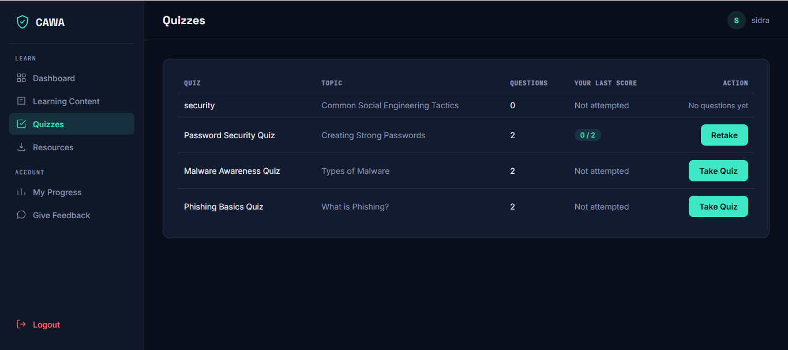

Figure 6.16: Quiz Interface

2.3 View Quiz Result
Steps:
- After submitting the quiz, results are displayed.
- View your score and correct answers.
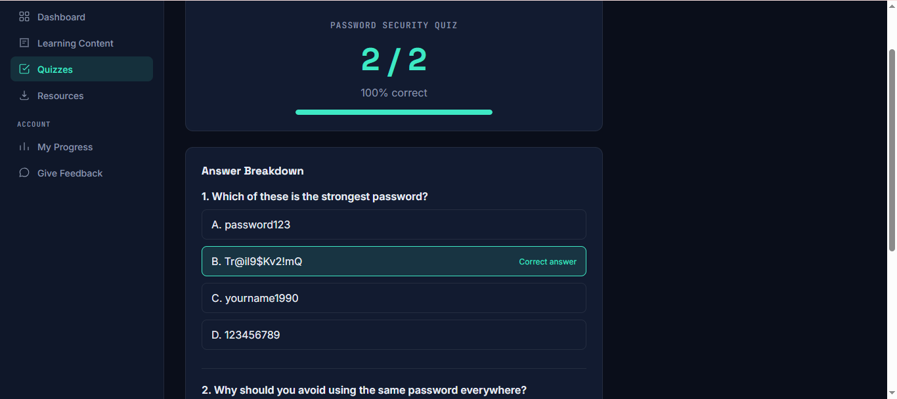

Figure 6.17: Quiz Result Page

2.4 Download Resources
Steps:
- Go to the Resources Section.
- Select a file (PDF).
- Click Download to save the file.
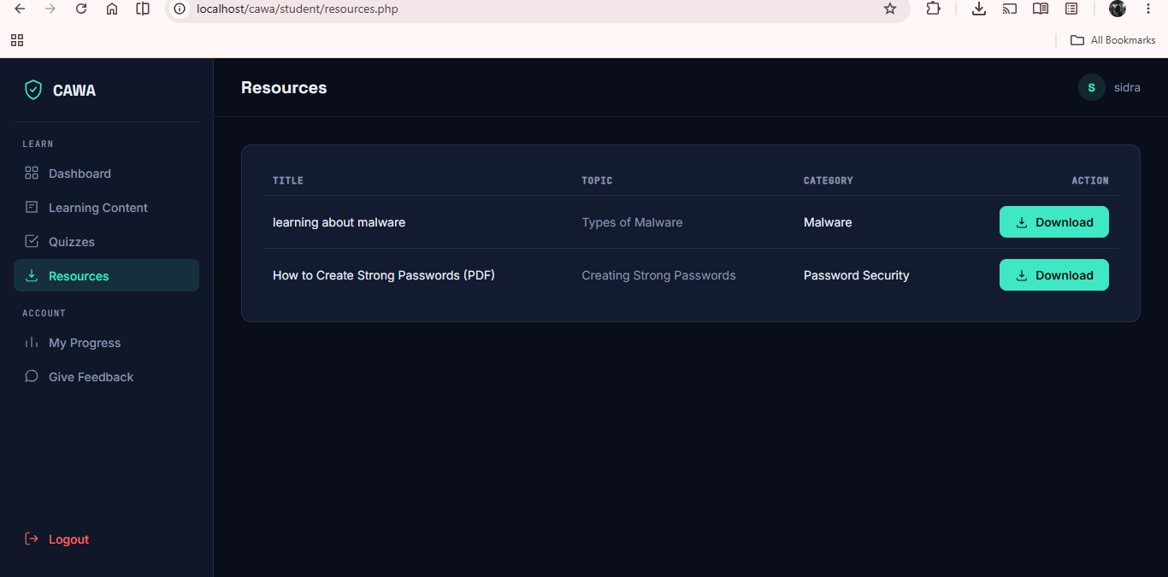

Figure 6.18: Resource Download Page

3. Admin Operations
(Admin users only)

3.1 Admin Login
- Login using admin credentials to access dashboard.

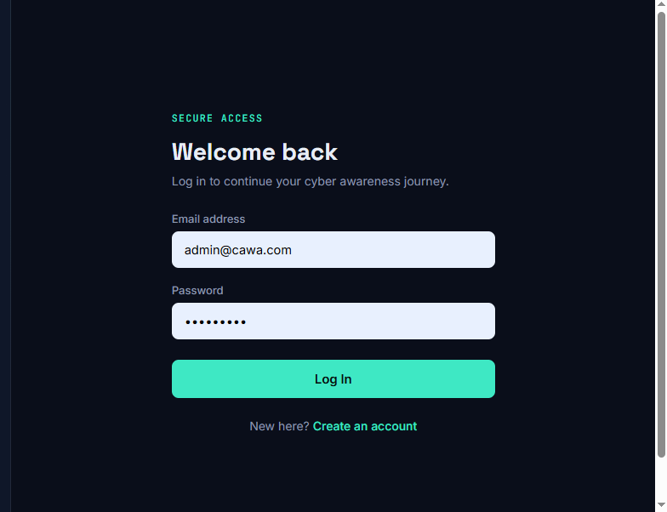
Figure 6.19: Admin Login Page

3.2 Manage System Data
Steps:
- Open Admin Dashboard.
- Manage:
  - Users
  - Topics
  - Quizzes
  - Resources
- Add, edit, or delete records.


Figure 6.20: Admin Dashboard

4. Generate Reports

Steps:
- Navigate to the Reports Section (Admin).
- Select report type (e.g., user activity, quiz results).
- View summarized data.
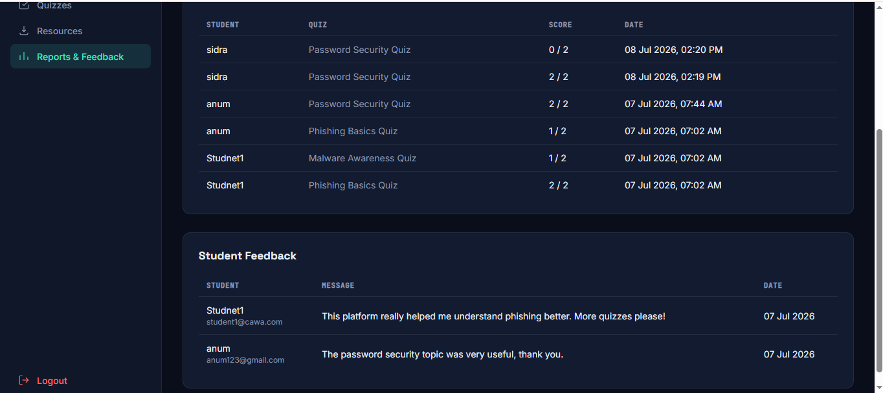

Figure 6.21: Reports Interface

Chapter 7: Conclusion and Future Enhancement

7.1 Conclusion
The Cyber Awareness Web Application (CAWA) was developed with the aim of providing a centralized, interactive, and user-friendly web-based platform that educates users about cybersecurity threats and promotes safe online behavior. The system was designed to address the key problems identified at the start of this project — the lack of structured, accessible, and interactive cybersecurity awareness resources for general internet users.
All objectives defined for this project have been successfully achieved. The system provides structured educational content covering major cybersecurity topics such as phishing, malware, password security, and social media safety. Registered students can access learning modules, attempt interactive quizzes, track their progress, and download PDF resources. Guests can browse public awareness content and register to access the full platform. The Administrator has complete control to manage users, topics, quizzes, categories, resources, and system reports through a dedicated dashboard.
During development and testing, the system was evaluated against the functional requirements defined in Chapter 2. All major modules — Authentication, Content Management, Quiz Module, Resource Management, and Admin Dashboard — were tested using black box testing techniques and performed as expected. The use of Core PHP with MySQL provided a stable and reliable backend, while HTML, CSS, Bootstrap, and JavaScript ensured a responsive and easy-to-navigate user interface.
Overall, the CAWA system successfully demonstrates how a simple, well-structured web platform can significantly improve cybersecurity awareness among non-technical users by replacing scattered, unstructured online resources with an organized, interactive, and centralized learning environment.

7.2 Limitations
Although the CAWA system fulfills its defined objectives, the following limitations exist:
- The system does not include video-based learning content; educational material is currently limited to text-based articles and downloadable PDF resources.
- There is no automated certificate generation for students who complete quizzes or learning modules successfully.
- The quiz module supports only text-based multiple choice questions; image-based or scenario-based questions are not currently supported.
- The system does not include a real-time notification feature to alert students about new content, quizzes, or resources added by the Admin.
- The platform is currently deployed on a local server and is not hosted on a public domain, which limits its accessibility to a wider audience.
- There is no discussion forum or community feature where students can interact with each other or ask questions related to cybersecurity topics.

7.3 Future Enhancements
The CAWA system can be extended further in the following areas to improve its functionality and reach:

7.3.1 Cloud Deployment
The system is currently hosted on a local server. In the future, it can be deployed on a cloud platform such as cPanel hosting, Amazon Web Services (AWS), or DigitalOcean to make it publicly accessible to students and general users from anywhere in the world, without being restricted to a local network..

7.3.2 Mobile Version
A dedicated mobile application (Android/iOS) can be developed for the CAWA platform, allowing students to access cybersecurity learning content, attempt quizzes, and download resources directly from their smartphones. This would make the platform more convenient and accessible for users who primarily use mobile devices.

7.3.3 AI Integration
Artificial Intelligence can be integrated into the system in multiple ways. An AI-powered chatbot can be added to answer student queries about cybersecurity topics in real time. Additionally, a recommendation engine can be developed to suggest personalized learning content and quizzes to each student based on their quiz results and learning history, improving the overall learning experience.

Chapter 8: References

8.1 References
[1] S. Bada, A. Sasse, and J. Nurse, "Cyber Security Awareness Campaigns: Why do they fail to change behaviour?" International Conference on Cyber Security for Sustainable Society, 2019. [Online]. Available: https://arxiv.org/abs/1901.02672
[2] K. Parsons, A. McCormac, M. Butavicius, and L. Ferguson, "Human Factors and Information Security: Individual, Culture and Security Environment," Command, Control, Communications and Intelligence Division, DSTO, Australia. [Online]. Available: https://www.researchgate.net/publication/265399045
[3] A. Aldawood and G. Skinner, "Reviewing Cyber Security Social Engineering Training and Awareness Programs — Pitfalls and Ongoing Issues," Future Internet, vol. 11, no. 3, p. 73, MDPI, 2019. [Online]. Available: https://www.mdpi.com/1999-5903/11/3/73
[4] M. Zwilling et al., "Cyber Security Awareness, Knowledge and Behavior: A Comparative Study," Journal of Computer Information Systems, Taylor & Francis, 2020. [Online]. Available: https://www.tandfonline.com/doi/full/10.1080/08874417.2020.1712269
[5] A. Aloul, "The Need for Effective Information Security Awareness," Journal of Advances in Information Technology, vol. 3, no. 3, 2012. [Online]. Available: https://www.jait.us/index.php/jait/article/view/JAIT-Vol3-No3-176
[6] PHP Group, "PHP Official Documentation," [Online]. Available: https://www.php.net/docs.php
[7] MySQL, "MySQL 8.0 Reference Manual," Oracle Corporation, [Online]. Available: https://dev.mysql.com/doc/refman/8.0/en/
[8] Bootstrap Team, "Bootstrap Documentation," [Online]. Available: https://getbootstrap.com/docs/
[9] OpenJS Foundation, "jQuery API Documentation," [Online]. Available: https://api.jquery.com/
[10] Mozilla Developer Network, "JavaScript Reference," MDN Web Docs, [Online]. Available: https://developer.mozilla.org/en-US/docs/Web/JavaScript
[11] OWASP Foundation, "OWASP Top Ten — Web Application Security Risks," [Online]. Available: https://owasp.org/www-project-top-ten/
[12] National Cyber Security Centre (NCSC), "Cyber Awareness Resources," [Online]. Available: https://www.ncsc.gov.uk/section/information-for/individuals-families

